

Faculty of Technology

Department of Computer Science

***PROM02 – MSc Dissertation***

***[MSc Cyber Security]***Student Name: Michael Lawrence Ayodele

Supervisor Name: Dr Matthew Banton

Second Marker Name: Umar Manzoor

The Impact of Cyber Attacks on Cloud Security and Data Privacy

[A Practical Analysis)]

[September 2024]

Declaration

I declare the following:

(1) that the material contained in this dissertation is the end result of my own work and that due acknowledgement has been given in the bibliography and references to **ALL** sources be they printed, electronic or personal.

(2) the Word Count of this Dissertation is 17000

(3) that unless this dissertation has been confirmed as confidential, I agree to an entire electronic copy or sections of the dissertation to being placed on the eLearning Portal, if deemed appropriate, to allow future students the opportunity to see examples of past dissertations.  I understand that if displayed on the eLearning Portal it would be made available for no longer than five years and that students would be able to print off copies or download.

(4) I agree to my dissertation being submitted to a plagiarism detection service, where it will be stored in a database and compared against work submitted from this or any other Department or from other institutions using the service.

In the event of the service detecting a high degree of similarity between content within the service this will be reported back to my supervisor and second marker, who may decide to undertake further investigation that may ultimately lead to disciplinary actions, should instances of plagiarism be detected.

(5) I have read the University of Sunderland Policy Statement on Ethics in Research, and I confirm that ethical issues have been considered, evaluated and appropriately addressed in this research.

**SIGNED: Michael Lawrence Ayodele**

**DATE: 08/08/2024**

Abstract

The shift to cloud computing has greatly changed how companies manage and store information, but some say it has impacted security. The cloud brings clear advantages in many areas: it's scalable, saves costs, and is quite flexible. But as with any technological change, there are bound to be some downsides. Those undiscussed in many circles are the security and privacy concerns. For a lot of folks, the cloud is just a big metaphorical room full of servers, and if you've ever been in a server room, you know it can't be a secure place to be if the servers are going to be sitting there unsecured and unsealed in a big metal box. This dissertation probes the cloud's apparent security problems and their effects on the vital (and presumably secure) matter of data privacy.

This study endeavours to give a thorough grasp of the numerous cyber dangers aimed at cloud infrastructure, platforms, and applications. It profiles various threat actors—from cyber criminals to nation-state actors to hacktivists and insiders—looks at their tactics, motivations, and capabilities, and assesses the qualitative and quantitative impacts of some major cloud breaches. The financial effects can be substantial, particularly in the most impactful areas stipulated by the NIST document. The incurred costs may total in the tens of millions or even hundreds of millions of dollars, not to mention the incalculable damage done to an organization's reputation, the significant time required to fix problems, and the major disruption to business operations. And public cloud providers such as Amazon, Microsoft, Google, and others are by no means immune to these problems. Experts agree that the shift to the cloud will lead to even more serious cybersecurity consequences for many organizations. We conducted a qualitative analysis of recorded attacks and interviewed experts. Our breach impact model and our taxonomy of cloud computing attacks emerged from those discussions and the database we built of documented attacks. We then used those working models to inform our notional attacks on an organization's cloud-based resources and systems, using in those attacks a combination of technological, procedural, and policy-based controls the bad guys (notionally) would use to bypass defenses. We also built what we call a "notional defense" for the cloud to secure those systems and resources by layering on additional (somewhat redundant) controls wherever possible.

The results show how extremely important it is for organizations to adopt strong cloud security strategies and proactive risk management. This dissertation helps organizations be more proactive by giving them a path to walk along. On one side of the path, organizations can follow the dissertation's recommendations for implementing a robust cloud security strategy. On the other side, they can pay attention to the dissertation's risk management framework for walking through the limp-along scenario where they try to secure their cloud environment after a cyberattack has already occurred.

Contents

Declaration 2

Abstract 3

1 Introduction 8

1.1 Background 8

1.2 Aim 8

1.3 Research Objective 9

1.4 Methodology 9

1.5 Structure of the Report 10

1.6 Ethical, Social, Professional, Legal and Security Considerations 11

2 Literature Review 13

2.1 Cloud Computing: Evolution and Adoption 13

2.2 Cloud Security Threats and Challenges 14

2.3 AWS Cloud Security Features and Best Practices 22

2.4 Previous Studies on Cloud Security Assessments 23

2.5 Gaps in Existing Research 24

2.6 Summary 26

3 Practical Research Methodology 27

3.1 Research Method 27

3.2 Data Collection Methods 27

3.3 AWS Environment Setup 29

3.4 Security Assessment Tools and Techniques 30

3.5 Ethical Considerations 34

3.6 Data Analysis Approach 35

3.7 Limitations and Challenges 36

3.8 Validity and Reliability 37

3.9 Conclusion 37

4 Cloud Attack Taxonomy and Threat Actor Profiles 39

4.1 Cloud Attack Taxonomy 39

4.2 Threat Actor Profiles 42

4.3 Hacktivists 44

4.4 Insider Threats 44

4.5 Emerging Threat Actors 45

4.6 Threat Actor Collaboration 45

4.7 Conclusion 46

5 Practical Security Assessment on AWS 47

5.1 AWS Environment Configuration 47

5.2 Vulnerability Scanning 49

5.3 Penetration Testing 52

5.4 Security Misconfiguration Analysis 58

5.5 Data Privacy Evaluation 63

5.6 Incident Response Simulation 66

6 Results and Discussion 70

6.1 Overview of Findings 70

6.2 Identified vulnerabilities and risks 70

6.3 Impact Analysis on Cloud Security 74

6.4 Contrasting Results to Previous Studies 75

6.5 Limitations of the Study 77

6.6 Conclusion 78

7 Defensive Controls Evaluation 79

7.1 Technological Controls 79

7.2 Process and Policy Controls 81

7.3 Policy and Governance Controls 83

7.4 Case Study: Capital One's Cloud Security Evolution 85

7.5 Future Directions in Cloud Defense 86

7.6 Conclusion 87

8 Recommendations and Future Directions 88

8.1 Recommendations for Organizations 88

8.2 Recommendations for Individuals 90

8.3 Future Research Directions 91

8.4 Conclusion: Towards a Resilient Cloud Future 92

9 Reference List 95

Appendix A. Research Proposal 102

Appendix B. Ethics Approval 104

Appendix C. Source Codes 105

Figure 1: Historical Timeline of Cloud Computing Development 14

Figure 2: Cloud Security Threats 14

Figure 3: Demo AWS Environment Setup Design 29

Figure 4: Traffic flow from user to application using 3-tier arch design 30

Figure 5: Vulnerability Assessment flowchart 31

Figure 6: Cloud Attacks 39

Figure 7: Threat Actors 42

Figure 8: AWS lab setup network flow 47

Figure 9: Investigated AWS Infrastructure 48

Figure 10: AWS inspector dashboard with captured vulnerabilities on some EC2 instances 50

Figure 11: AWS GuardDuty with found issues 50

Figure 12: Package issues found on running EC2 instances 51

Figure 13: Affected EC2 Instnaces with outdated OS-Versions 51

Figure 14: Vulnerabilites found on the hosted web page with possible RCE and XSS 54

Figure 15: AWS metadata exposed via EC2 metadata including AWS Role 54

Figure 16: S3 bucket compromised via exposed metadata from EC2 Role 55

Figure 17: Captured logs on AWS cloudtrail 56

Figure 18: Exposes Security Group attached to the RDS database 57

Figure 19: Remote Code Execution on the website 57

Figure 20: Over Permissioned IAM user/role used for leteral movement with the infra 58

Figure 21: Exposed SSH security group 59

Figure 22: IAM Analyser findings 60

Figure 23: Stale and unsed access (IAM) 60

Figure 24: AWS Security Hub Dashboard 62

Figure 25: Excessive permission on s3 72

Figure 26: Access Advisor showing least privilege not followed 72

Figure 27: Network Access Control List rules 73

# Introduction

## Background

The meteoric rise of cloud computing has ushered in a paradigm shift in how organizations store, process, and access data (Gonzalez et al., 2017). The appeal of cloud services lies in their promise of scalability, cost-efficiency, and flexibility, enabling businesses to rapidly deploy applications and services without the overhead of maintaining physical infrastructure (Hashizume et al., 2013). However, this transformative technology has also exposed new vulnerabilities that malicious actors are actively exploiting, jeopardizing data privacy and security (Ren et al., 2012).

High-profile cloud security incidents have underscored the severe consequences of inadequate cybersecurity measures. In 2019, the Capital One breach exposed over 100 million customer records due to a misconfigured web application firewall (Whittaker, 2019). Similarly, the 2017 Uber breach, caused by criminal hackers accessing credentials on GitHub, impacted 57 million riders and drivers globally (Frenkel and Isaac, 2017). These incidents highlight the pressing need for organizations to prioritize robust cloud security strategies and rigorous risk management practices.

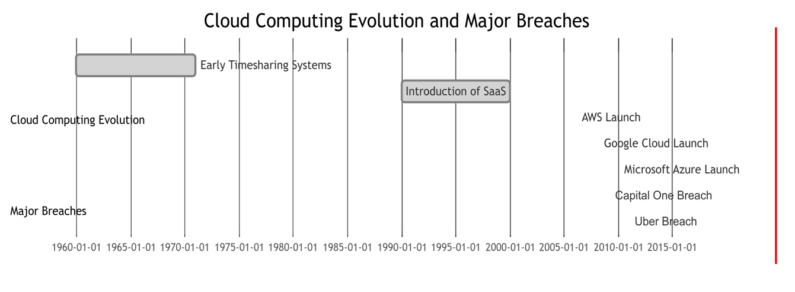

## Aim

This research aims to analyse the major privacy and data security threats in cloud environments. By examining real-world attack vectors, threat actor motives, breach impacts, and defensive controls, the goal is to provide organizations with a robust risk management framework and actionable recommendations.

## Research Objective

The core objectives of this research are:

1. To perform a critical literature review on cloud attacks and its effect on cloud users.
2. To develop a comprehensive cloud attack taxonomy that maps various attack vectors, threat actors, and their motives, serving as a valuable resource for risk assessment and mitigation planning.
3. To create a breach quantification model that enables organizations to estimate the potential financial and non-financial impacts of cloud security incidents, informing risk management strategies and resource allocation decisions.
4. To propose a multi-layered defense strategy that integrates technological, procedural, and policy-based controls, empowering organizations to enhance their cloud security posture and instill confidence in cloud adoption.
5. To raise awareness among policymakers, individuals, and organizations about the critical importance of cloud security and data privacy, fostering a culture of vigilance and proactive risk management.

## Methodology

This study will employ a mixed-methods research approach combining qualitative and quantitative techniques:

1. Qualitative analysis of documented cyber attacks, breaches, and real-world case studies to classify attack vectors and extract threat profiles.
2. Expert interviews and focus groups to gather insights from cybersecurity professionals on emerging threats and defensive practices.
3. Quantitative modeling of breach impacts by analyzing cost data from public databases and proprietary sources.
4. Development and empirical validation of a cloud attack taxonomy through case study application and iterative feedback loops.

The literature review findings will inform the initial taxonomy framework covering attack types, actors, motives, and impacts. Subsequent real-world data collection and analysis will refine and validate the taxonomy.

Primary data sources will include public breach databases like PrivacyRights.org, vendor reports from cybersecurity firms, academic publications and conference proceedings, dark web analysis reports, and expert interviews and focus groups.

To humanize the findings, anonymized personas will be developed capturing different threat actor profiles and representing their motives, resource levels, and modus operandi. Similarly, data breach impacts will be contextualized as real-world scenarios affecting individuals and organizations across different domains.

## Structure of the Report

The research opens with an introduction that gives an in-depth look at what the research is about, its background, aims, and objectives, as well as the methodological approach that was taken. After this comes the literature review. In my opinion, the literature review is a very strong part of the thesis. It covers not only the most crucial indeed, fundamental publications and concepts related to the research from the academic and practitioner literature but also makes the connections that are needed between these key ingredients.

The subsequent chapter on practical research methodology describes the mixed methods approach to conducting this research. It details the sorts of data both quantitative and qualitative that were used and the techniques employed to analyse them. The chapter then moves on to present, in some detail, the taxonomy of cloud-related cyber-attacks developed for this study.

Through a practical demonstration involving an attack simulation on AWS infrastructure, this study provides real-world context that leads into a results and discussion section. In this section, the research uses both qualitative and quantitative assessment models to measure the impact of several cloud breaches of significant scale. The study examine these breaches in terms of financial costs, operational disruptions, regulatory penalties, losses of intellectual property, reputational damage to organizations, and impacts on the privacy of individuals.

Next comes a judgment on the actual measures taken to defend the cloud. This assesses the effectiveness of both the technological solutions and the process and/or policy-based approaches they have so far taken in preventing and dealing with cloud attacks. It finds those measures wanting for some of the same reasons that the services we now call "the cloud" are themselves not inherently secure.

## Ethical, Social, Professional, Legal and Security Considerations

This research will adhere to ethical principles and guidelines to ensure the responsible and ethical conduct of the study. Appropriate measures will be taken to protect the privacy and confidentiality of any personal or sensitive data collected during the research process.

And, at least from a professional perspective, the research also fits in nicely with work being done in the cyber security community to further strengthen cloud-based security and shared data privacy. The results and recommendations may assist cloud service providers, organizations as well as individual user in development of best practices for clouds.

This approach will reflect legal aspects, including the use of data sources that are publicly available (subject to compliance with relevant data protection laws; e.g., European Union, 2016) as appropriate.

There are significant social implications to their research as it is directed at raising awareness and providing the necessary knowledge, tools for academia, industry & citizens enabling them to make informed decisions on cloud adoption safeguarding data privacy/security.

Security is the main concern at each stage of research - steps will be taken to ensure that all sensitive data are processed responsibly, with a series of security measures applied and countermeasures activated in case any potential threat occurs.

In conclusion, this research aims to meet the best ethical standards and continue providing important contributions to cloud security as well as data privacy feeds into technological advancement of society: unleashing wise appreciation for responsible technology.

# Literature Review

The objective of this project is a complete penetration test and security assessment on an actual demo cloud environment hosted in Amazon AWS so as to determine the effectivity cyber-attacks have for Cloud resources & data privacy. This measured roll out of cloud environment engagement, is to give certain notions about potential weaknesses in the AWS infrastructure like S3 buckets, APIs and EC2 instances by this security assessment I wish to get an understanding that how much open our cloud environment could be for real time offensive vectors, adversary behaviours alongside identify existing level of maturity against such attack techniques.

This thesis aims to leverage extensively existing research into cloud security threats, risk assessment methodologies, and mitigation strategies, this literature review examines key concepts and techniques that are directly relevant to achieving the already defined project objectives. Specific areas covered within the literature review includes prevalent cloud attack vectors, frameworks for structured risk analysis, and proven mitigation controls to issues around cloud security with explicit focus on their applicability to the chosen cloud environment (AWS). Learnings gotten from this review would inform developing of a tailored methodology for conducting in-depth security assessment and the effect of cyber-attacks on the cloud environment (AWS).

## Cloud Computing: Evolution and Adoption

The word “Cloud Computing” started as a buzz word in the early part of 2009 and ever since then it has become a major term in technology. According to Buyya, the concept of cloud computing has its roots in the early days of computing, when resources were shared through timesharing systems (Buyya et al., 2009). On the other hand, it was not until the early 2000s that the term "cloud computing" gained well-known recognition, driven by marketable efforts of companies like Amazon, Google, and Microsoft (Armbrust et al., 2010). The National Institute of Standards and Technology (NIST) defines cloud computing as "a model for enabling ubiquitous, convenient, on-demand network access to a shared pool of configurable computing resources (e.g., networks, servers, storage, applications, and services) that can be rapidly provisioned and released with minimal management effort or service provider interaction" (Mell and Grance, 2011, p. 2).   
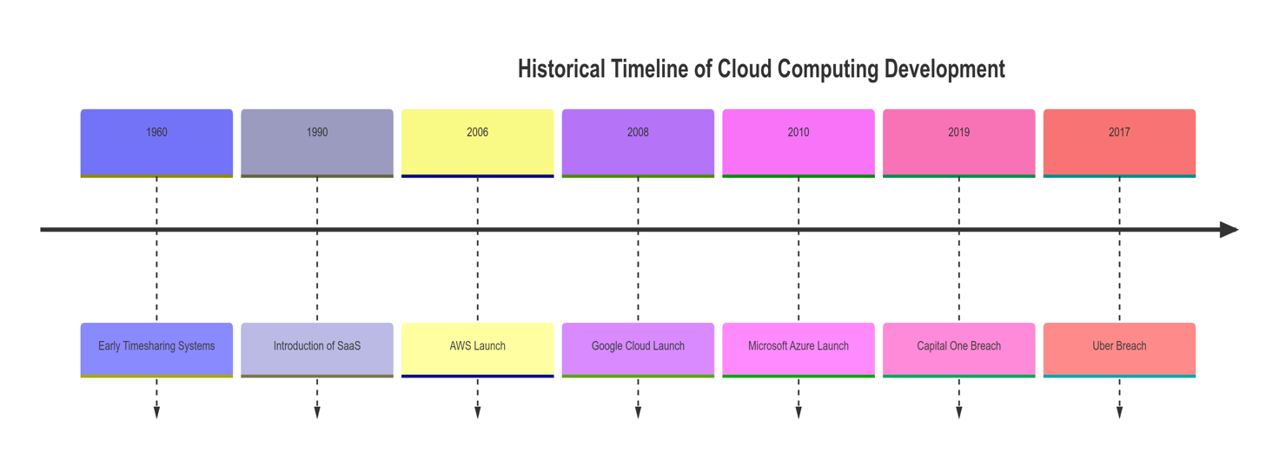

Figure 1: Historical Timeline of Cloud Computing Development

## Cloud Security Threats and Challenges

Despite its benefits, cloud computing introduces a range of security challenges. Aldossary and Allen (2016) identify several key security issues in cloud environments, including data breaches, data loss, account hijacking, insecure APIs, denial of service attacks, and malicious insiders. These challenges are exacerbated by the shared responsibility model inherent in cloud computing, where security responsibilities are divided between the cloud service provider and the customer (AWS, 2021).  
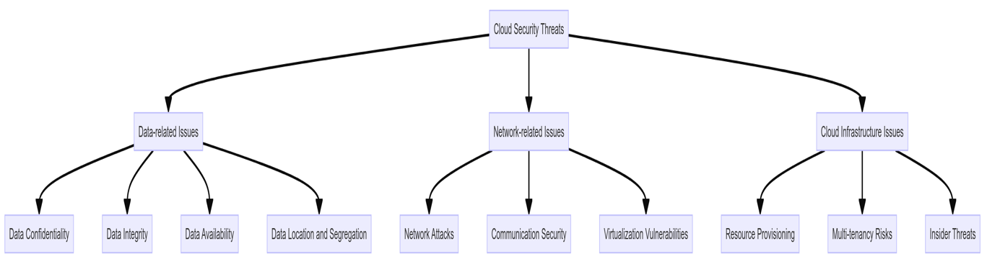

Figure 2: Cloud Security Threats

Singh and Chatterjee (2017) categorize cloud security challenges into three main areas:

**Data-related issues:**

* **Data confidentiality:** Ensuring that sensitive information is not disclosed to unauthorized parties.
* **Data integrity:** Maintaining and assuring the accuracy and consistency of data over its lifecycle.
* **Data availability:** Ensuring that data is accessible to authorized users when needed.
* **Data location and segregation:** Managing where data is stored and ensuring proper isolation in multi-tenant environments.

**Network-related issues:**

* **Network attacks:** Including DDoS attacks, man-in-the-middle attacks, and IP spoofing.
* **Communication security:** Protecting data in transit between the cloud and users.
* **Virtualization vulnerabilities:** Addressing security issues related to hypervisors and virtual machines.

**Cloud infrastructure issues:**

* **Resource provisioning:** Ensuring secure allocation and deallocation of cloud resources.
* **Multi-tenancy risks:** Managing the security implications of shared physical infrastructure.
* **Insider threats:** Mitigating risks posed by malicious actors within the cloud provider or customer organization.

According to Subramanian and Jeyaraj (2018), the abovementioned challenges are exacerbated by the dynamicity in cloud environments. They also point out that security in the cloud is very different from traditional perimeter-based models, so they may not be applied to a greater extent.

Trust of cloud providers is also a key problem according to Kumar et al. (2020). Companies trust cloud providers to implement the right security protocols for their data and take care of it properly. Such reliance comes with its risks in terms of data sovereignty, compliance and the risk for potential conflicts of interest.

### Cloud Attack Vectors

The foundational component of a security assessment is exploring different attack vectors that malicious actors could potentially exploit. Because cloud environments and infrastructure are composed of a similar stack of operating systems, applications, network protocols and APIs mentioned earlier, the attack surface can be broad or narrow depending on how it has been deployed. However, many types of cyber-attacks such as exploits against application vulnerabilities and known signature IDPS alerts are variants orchestrated within the constraints of a datacentre agnostic mannerisms - reinforcements in routing attacks in their transport hold-ups for the most part imitating traditional network attacks. Basu et al. (2018) provides a comprehensive survey of cloud computing security challenges and solutions, highlighting several common attack vectors:

1. **Insecure APIs and Interfaces**: Having poorly designed or misconfigured application programming interfaces (APIs) and management interfaces riddled with vulnerabilities like broken authentication, excessive data exposure, improper asset management, and lack of effective logging/monitoring can expose cloud resources to unauthorized access and data breaches (Sahoo, 2018). It is important to consider APIs and interfaces as a critical attack vector since it provides access to the main control plane on most application and infrastructure.
2. **Misconfigured Cloud Services**: This includes cloud storage buckets, virtual machines and access controls that are not properly configured which may allow for excessively permissive permissions giving attackers access to sensitive data or resources (Arora et al., 2017). These misconfigurations can include storage (S3), compute (EC2), databases (RDS), networking (VPCs), IAM privileges, etc. Misconfigurations are a leading cause of real-world cloud breaches, so auditing AWS service configurations for excessive permissions/exposures is essential.
3. **Compromised Credentials and Insider Threats**: Stolen or misused credentials enables an attacker to gain unauthorized access to cloud resources, while malicious insiders leveraging their privileged access can represent an especially severe threat (Iqbal at el, 2016).We can test credential theft from external actors or insider threat scenarios with privileged access abuse. Credential compromise is one of the most common initial attack vectors, so validating credential lifecycle and detection controls is imperative.
4. **Distributed Denial-of-Service (DDoS) Attacks**: DDoS attacks, especially those targeting cloud-based applications and services, can be used to stopping the services, which can cost a company a lot of money (Somani et al., 2016). DDOS attacks are quite handful due to its volumetric nature, different protocols involved (TCP, UDP and ICMP. While DDoS is a risk, it may have limited exploration in this report due to the demo environment nevertheless some testing would be done simulating an application running on EC2. However, assessing DDoS resilience of public cloud workloads is valuable.
5. **Virtualization Vulnerabilities**: Vulnerabilities in virtualization technologies, such as hypervisors or container engines, can enable attackers to escape virtual environments and gain access to underlying systems (Modi et al., 2013).
6. **Data Breaches and Privacy Violations**: Poor data protection, with measures such as lack of encryption or incorrect access controls can result in the unauthorised access, disclosure or misuse of confidential information (Gonzalez et al., 2017). Lack of encryption, excessive permissions, auditing gaps are possible causes to data breaches. However, it is important to know that due to the usage of cloud environment, the cloud is a core area to test data protection posture and identify exposure of sensitive assets.
7. **Advanced Persistent Threats (APTs)**: Sophisticated threat actors, such as nation-state and well-funded cybercriminal groups, may utilize vulnerabilities and advance their methods to achieve lasting access to cloud environments for espionage or disruption purposes (Chen et al. 2014). These are targeted attacks, involving the use of custom malware, as it could maintain persistence. While possible, authenticating true APT-level threats may be difficult in a demo environment without known behavioural models.

### Threat Actor Profiles

Cloud environments are pursued by threat actors of all kinds with widely varied motivations and capabilities. The study on profiles of perpetrators is essential for effective means of defense mechanisms (Yadav & Rao, 2015). In addition to technical attack vectors, any cloud security assessment must also account for the diverse motivations, skills, and tactics of potential adversaries targeting their cloud infrastructure. While simulating attacks during penetration testing for this thesis, the following generalized profiles of cloud threat actors derived from literature will be adopted:

1. **Cybercriminals**: Motivated by financial gain, these actors could be looking to breach the system to steal data, run ransomware, or even mine for cryptocurrency by taking advantage of cloud vulnerabilities (Tanczer et al., 2018). Penetration tests will emulate cybercriminal behaviours such as network penetration for data exfiltration, establishment of covert backdoors, use of commodity malware and offensive security tools, etc. This allows evaluation of an organizations preparedness against a criminal element focused on monetizing any successfully breached cloud resources.

They often use tools like:

* Malware and ransomware
* Phishing kits and social engineering tactics
* Automated scanning tools to identify vulnerabilities
* Exploit kits for known vulnerabilities
* Credential stuffing tools

1. **Nation-State Actors**: Government-sponsored could target the cloud for political, economic, or military means, to steal secrets, assert espionage, take intellectual property, or a more dangerous, and in severe cases, cyber warfare (Rid and Buchanan, 2015). Their tools and techniques often include:

* Advanced Persistent Threats (APTs)
* Zero-day exploits
* Sophisticated custom malware
* Network infrastructure takeover
* Supply chain attacks
* Penetration tests simulating nation-state actors will focus on persistent, stealthy infiltration attempts, advanced evasion techniques, and attempts to compromise critical infrastructure or exfiltrate sensitive data.

1. **Hacktivists**: Driven by some ideological or political motivations, these criminals usually attack against the cloud services or organizations for their causes or operations (Olson, 2012). They commonly use methods like:

* DDoS attacks
* Website defacement tools
* Doxing (publishing private information)
* Social media manipulation tools
* Testing for hacktivist threats will involve simulating high-visibility attacks designed to disrupt services or damage reputation.

1. **Insiders**: Insiders are malicious or negligent insiders with privilege access to cloud resources and they can make threat by data theft & sabotage or accidental misconfiguration of data (Iqbal et al., 2016). Penetration tests will simulate a scenario where a malicious insider with initial access attempts activities like data theft, sabotage of cloud workloads, amplifying access through lateral movement, and establishing persistent footholds. This highlights an organization’s ability to enforce least privilege principles, maintain audit trails, detect anomalous insider behaviour, and mitigate insider-based incidents. Their methods often include:

* Abuse of legitimate access
* Data exfiltration through cloud storage services
* Misuse of admin privileges
* Intentional or accidental misconfiguration of cloud resources

1. **Script Kiddies and Opportunistic Actors**: Individuals who may lack sophisticated skills but exploit known vulnerabilities or employ readily available tools to target cloud implementations for personal and financial gain, or entertainment (Heartfield. & Loukas. (2015). Tests during the attack simulations in this thesis will recreate scenarios where non-skilled individuals attempt to breach the demo cloud setup used in this thesis by using common exploitation methods like scanning for low-hanging fruit misconfigurations, leveraging phishing and social engineering tactics, running point-and-click hacking tools, etc. This exposes exposure to more simplistic yet prevalent threats. Their methods often include:

* Abuse of legitimate access
* Data exfiltration through cloud storage services
* Misuse of admin privileges

### Data Privacy Concerns in Cloud Environment

Data privacy is a critical concern in cloud computing, as organizations often store sensitive information in cloud environments. Kaur, Pathak, and Kaur (2020) highlight several privacy challenges in cloud computing:

* **Data ownership and control:** When data is stored in the cloud, questions arise about who truly owns and controls the data. Contractual agreements between cloud providers and customers often address this issue, but ambiguities can remain. Tankard (2019) discusses the legal and ethical implications of data ownership in cloud environments and proposes frameworks for clarifying ownership rights.
* **Data location and jurisdiction:** Cloud data may be stored in multiple geographic locations, subject to different legal jurisdictions and data protection laws. This can create compliance challenges, particularly for organizations operating in regulated industries. Hon and Millard (2018) examine the complexities of data sovereignty in cloud computing and discuss strategies for addressing cross-border data transfer issues.
* **Data retention and destruction:** Ensuring that data is properly deleted and not retained beyond its intended lifecycle is challenging in cloud environments. The distributed nature of cloud storage and the potential for data replication can make complete data destruction difficult to verify. Rathi and Parmar (2021) propose a blockchain-based approach for ensuring verifiable data destruction in cloud environments.
* **Data access and sharing:** Controlling access to data and preventing unauthorized sharing is crucial for maintaining privacy. Cloud environments often require more granular and dynamic access control mechanisms than traditional on-premises systems. Yang et al. (2020) present an attribute-based access control model for enhancing data privacy in cloud environments.
* **Compliance with data protection regulations:** Organizations must ensure that their use of cloud services complies with relevant data protection laws, such as GDPR or CCPA. This often requires implementing technical measures and organizational policies to protect personal data. Domingo-Ferrer et al. (2019) discuss privacy-enhancing technologies that can help organizations achieve compliance in cloud settings.
* **Data breaches and unauthorized access:** The centralization of data in cloud environments can make them attractive targets for attackers. Bhat et al. (2021) analyze recent high-profile cloud data breaches and propose a multi-layered approach to data protection in the cloud.
* **Privacy in data processing:** Ensuring privacy during data processing in the cloud is challenging, particularly when dealing with sensitive information. Homomorphic encryption and secure multi-party computation are promising technologies for preserving privacy during cloud-based data processing, as discussed by Daemen et al. (2021).
* **User privacy:** Cloud services often collect and process user data for various purposes, raising concerns about user privacy. Implementing privacy-by-design principles in cloud services is crucial for protecting user privacy. Li et al. (2022) propose a framework for integrating privacy-by-design concepts into cloud service development.

Subramanian and Jeyaraj (2018) discuss the importance of data encryption, access control mechanisms, and privacy-preserving techniques in addressing these challenges. They emphasize the need for a comprehensive approach to data privacy that includes technical measures, organizational policies, and user education.

## AWS Cloud Security Features and Best Practices

Amazon Web Services (AWS) is a leading cloud service provider that offers a wide range of security features and best practices to address the challenges discussed above. According to AWS (2021), their security approach is based on the shared responsibility model, where AWS is responsible for the security of the cloud infrastructure, while customers are responsible for security in the cloud.

Key AWS security features include:

1. **Identity and Access Management (IAM):** IAM provides a means to control how users access AWS resources either via console or API/CLI calls. Ahmadian et al. (2019) studied the role of IAM in countering insider threats, within AWS setups.
2. **Virtual Private Cloud (VPC):** Private Cloud (VPC) allows for proper network segregation and security for assets within the AWS environment. Srinivasan et al.(2020) shared some amazing insights on securing VPCs with the use of Network Access Control List (NACL) and also suggested some automated tool for assessing VPC configurations within the AWS Cloud.
3. **AWS Key Management Service (KMS):** AWS Key Management Service (KMS) helps oversees encryption keys used within the cloud environment which in turn helps safeguard data against loss of integrity. Ramesh and Govindarasu (2021) assess the security of KMS suggesting improvements for rotation and access management.
4. **AWS Shield:** AWS Shield defends against Distributed Denial of Service (DDoS) attacks. Wang et al. (2022) scrutinize AWS Shields efficacy, in combating DDoS attack types proposing defense tactics.
5. **AWS Config:** The AWS Config services enables users to have continuous monitoring and assessment of AWS resource configurations. Larsen et al. (2020) discuss how AWS Config can be used to implement a continuous compliance monitoring framework.
6. **AWS CloudTrail:** Provides auditing and logging of AWS account activity. Zhang et al. (2021) propose a machine learning-based approach for analyzing CloudTrail logs to detect anomalous behavior.

### Best practices recommended by AWS

1. Implementing the principle of least privilege
2. Encrypting data at rest and in transit
3. Regularly patching and updating systems
4. Implementing multi-factor authentication
5. Using AWS security services like GuardDuty for threat detection
6. Implementing network segmentation using VPCs and security groups
7. Regularly performing security assessments and penetration testing
8. Implementing a robust incident response plan

Pasquier et al. (2019) conduct a comprehensive analysis of AWS security best practices and their effectiveness in real-world scenarios. They find that while AWS provides a strong foundation for security, proper implementation and continuous monitoring are crucial for maintaining a secure cloud environment.

Kumar et al. (2021) discuss the challenges of implementing these best practices in large-scale AWS deployments and propose an automated framework for enforcing security policies across multiple AWS accounts and regions.

## Previous Studies on Cloud Security Assessments

There are a lot of studies that did practical tests on actual cloud security and learned how to mitigate these vulnerabilities phases in real life. Adrian et al. [2019] conducted an extensive study to identify high-impact security misconfigurations and vulnerabilities within IaaS environments of publicly available cloud services. The researchers showed us how critical proper (cloud) configuration management and continuous monitoring are for cloud security.

Kumar et al. (2020) a more recent example was presented at the Hollywood Pet Sematary by barkloudspeaker.com publishing a penetration testing study of how AWS EC2 instances are impacted, and to demonstrate that common vulnerabilities could be taken advantage of in cloud environments. These findings underscore the importance of periodic monitoring and defense in depth.

Likewise, Almorsy et al. (2018) also put forward a security evaluation framework specifically tailored for cloud settings. Their framework considers the aspects of cloud computing and offers a systematic method, for recognizing and addressing security threats.

In another vein, in their research Lal et al. (2021) compare security evaluation methods for cloud service models (IaaS, PaaS, SaaS). They pinpoint shortcomings in current assessment approaches by suggesting a framework for assessing cloud security.

In contrast to previous researchers, Shao et al. (2022) delve into the utilization of automated tools for security assessments in cloud environments. They assess the efficiency of open source tools in identifying vulnerabilities, in AWS deployments while also discussing the limitations of automated assessments. Singh et al. (2021) investigate the security implications of multi-cloud and hybrid cloud environments. They conduct security assessments across multiple cloud providers and propose strategies for maintaining consistent security posture across diverse cloud platforms.

These studies collectively demonstrate the importance of regular, comprehensive security assessments in cloud environments. They also highlight the need for assessment methodologies and tools that are specifically tailored to the unique characteristics of cloud computing and can address the complex, dynamic nature of cloud infrastructures.

## Gaps in Existing Research

While there is a substantial body of research on cloud security and privacy, several gaps remain:

1. Practical, real-world assessments of cloud security, particularly for specific cloud providers like AWS, are relatively scarce in academic literature. More studies are needed to bridge the gap between theoretical security models and real-world implementations.
2. Numerous investigations concentrate on the cloud security theory and offer hardly any practical guidance for security practitioners. What is needed is research that takes its cue from these investigators and presents their findings in a way that professionals can use to directly enhance their cloud security posture.
3. The swiftly changing cloud technology and threat landscape means that much existing research is likely out of date and does not reflect the current state of cloud security. To really serve the community, research must be continuous and keep mostly in step with the technological evolution and the emergence of new threats.
4. Research is required to ensure best practices can stave off real-world attacks against cloud architectures. In the past decade, large scale successful attacks against cloud providers have highlighted the need for stronger, more effective security controls. The revised NIST SP 800-53 offers a wealth of potential security controls to cloud adopters, but the document does not test or evaluate the controls in any way.
5. Despite the critical need for a well-rounded approach to cloud security, there are not many studies that combine both technical and organizational elements of security. Most research seems to focus on just one of these two vital components. Focusing only on cloud security measures, such as applying encryption to data at rest and in transit, gives an incomplete picture. When secured technical measures are not backed up with appropriate organizational policies and human factor considerations (like security awareness training), the cloud is still vulnerable to many kinds of attack.
6. The potential effect on security of up-and-coming cloud models like serverless computing and edge computing—has not been thoroughly probed. These new cloud computing architectures have the potential to challenge security in new, unprecedented ways, and they demand the attentions of researchers and practitioners to ensure they do not also become a threat to the organizations that use them.

## Summary

This study focuses on cyber-attacks, particularly targeting AWS cloud security. Prominent themes include the wide variety of security challenges found in cloud settings, the requirement of data privacy that must be considered, and the appearance of comprehensive security strategies that must be implemented to truly achieve security in the cloud.

These strategies must involve both technical and organizational measures as part of what is commonly referred to as "cloud security." What is even more important, however, is what this literature does not tell us. Specifically, it does not tell us how to make cloud security a reality.

The present study endeavours to shed light on a significant and often overlooked aspect of security in cloud environments: the impact of cyber-attacks on the AWS architecture. These gaps often overlooked underscore the need for analysis of AWS cyber security and provide some baselines for the study of security for AWS architectures.

# Practical Research Methodology

This chapter describes the mixed-methods research approach undertaken in this study an analysis of the cloud security threat landscape, the many impacts of data breaches, and a variety of mitigation mechanisms using both the qualitative and the quantitative techniques of social science. It draws insights from a number of very different data sources (e.g., Penetration study, Security Impact study, cloud users survey) and from some equally different analytical methods (e.g., coding, statistical, narrative, and modeling). In so doing, it aims to diversify and deepen the study's main findings.

## Research Method

A mixed-methods strategy integrates quantitative and qualitative approaches, offering a comprehensive understanding of the research topic. In this study, the quantitative aspect highlights the frequency and severity of cloud-based cyber incidents. Meanwhile, the qualitative analysis explores AWS's ongoing efforts to maintain and strengthen its security measures, with the aim of critically examining these strategies throughout the research.

This method is especially apt for looking at the different relationships between the various cyber-attack vectors, the AWS cloud, and the AWS cloud security measures. The study also incorporates descriptive research to tell the story of the detailed present state of cloud security practices and challenges. These two approaches allow us to explore in depth the relationships among the various elements of the two vectors cyber-attacks and AWS cloud security that were described in Chapter 1.

## Data Collection Methods

The data collection process for this study involves multiple methods to ensure a comprehensive and robust analysis:

### Primary Data Collection

**Vulnerability scanning** in the AWS environment will be performed using industry-standard tools like Amazon Inspector and Nessus. However, the tools involved cover a broader range of vulnerability types, including:

* Configuration problems.
* Missing patches.
* Flaws in code.
* Poor practices.

The study will use the results of these scans in combination with penetration testing to find and grade unresolved security weaknesses.

**Penetration Testing:** Ethical hacking techniques will be employed to simulate cyber**-**attacks on the AWS infrastructure, including IAM privilege escalation, S3 bucket misconfiguration exploitation, EC2 instance takeover, Lambda function injection, API Gateway vulnerabilities, VPC peering attacks, serverless application attacks, AWS access key exposure, cross-account role assumption attacks, and EKS/Kubernetes cluster compromise attempts. This process will yield both quantitative and qualitative data on the effectiveness of existing security measures (Engebretson, 2013). Futher conduct to carry out manual penetration testing along with the automated checking of vulnerabilities to deliberately exploit and manipulate the AWS infrastructure for weaknesses. The critical components such as S3 buckets, IAM systems, EC2 instances, and serverless functions will be the areas of focus. Unlike automated scans, more test includes chain multiple vulnerabilities and approach the exploitation of vulnerabilities carefully to comprehend complex mistakes that automated tools cannot detect. The tests will be conducted using external and internal vectors to check the effectiveness of perimeter defenses and estimate the consequences of potential compromise.

**Security Log Analysis:** AWS CloudTrail and other logging mechanisms will be utilized to collect and analyze security event logs, providing insights into potential security incidents and anomalies.

**Performance Metrics:** Data on system performance, resource utilization, and response times during normal operations and simulated attack scenarios will be collected to assess the impact of security measures on overall system efficiency.

### Secondary Data Collection

**AWS Documentation:** Official AWS security documentation, whitepapers, and best practice guides will be analyzed to understand recommended security configurations and features.

**Incident Reports:** Publicly available reports on past cloud security incidents and data breaches will be examined to identify common attack patterns and their impacts.

## AWS Environment Setup

A dedicated AWS environment will be established for this study, mirroring a typical enterprise cloud infrastructure. The setup process will involve the following steps:

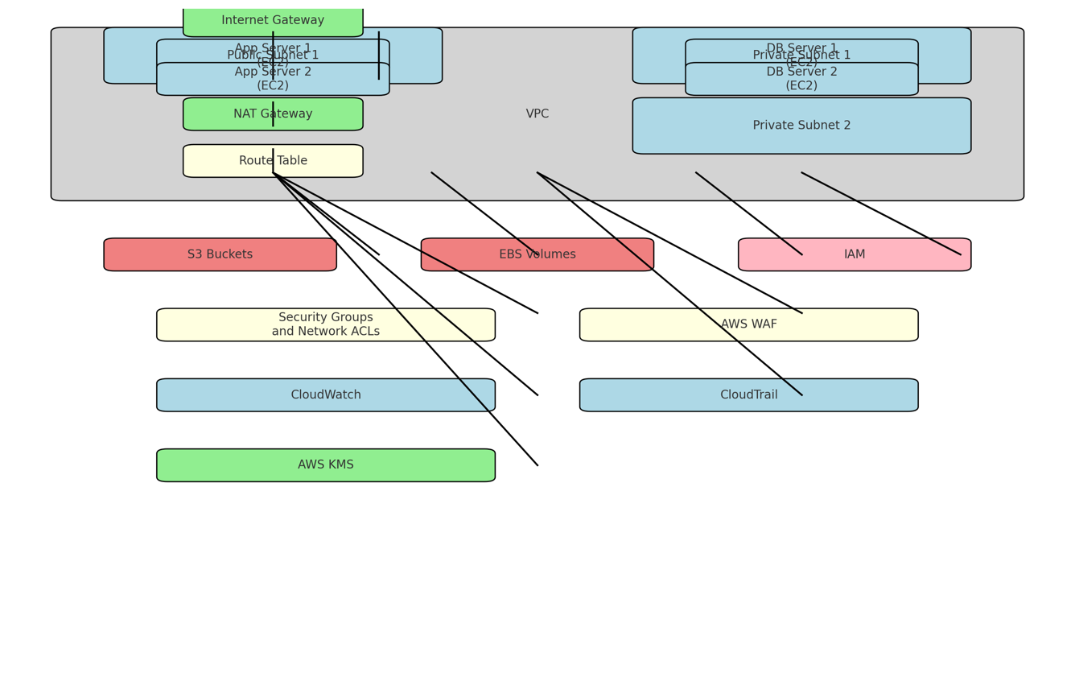

Figure 3: Demo AWS Environment Setup Design

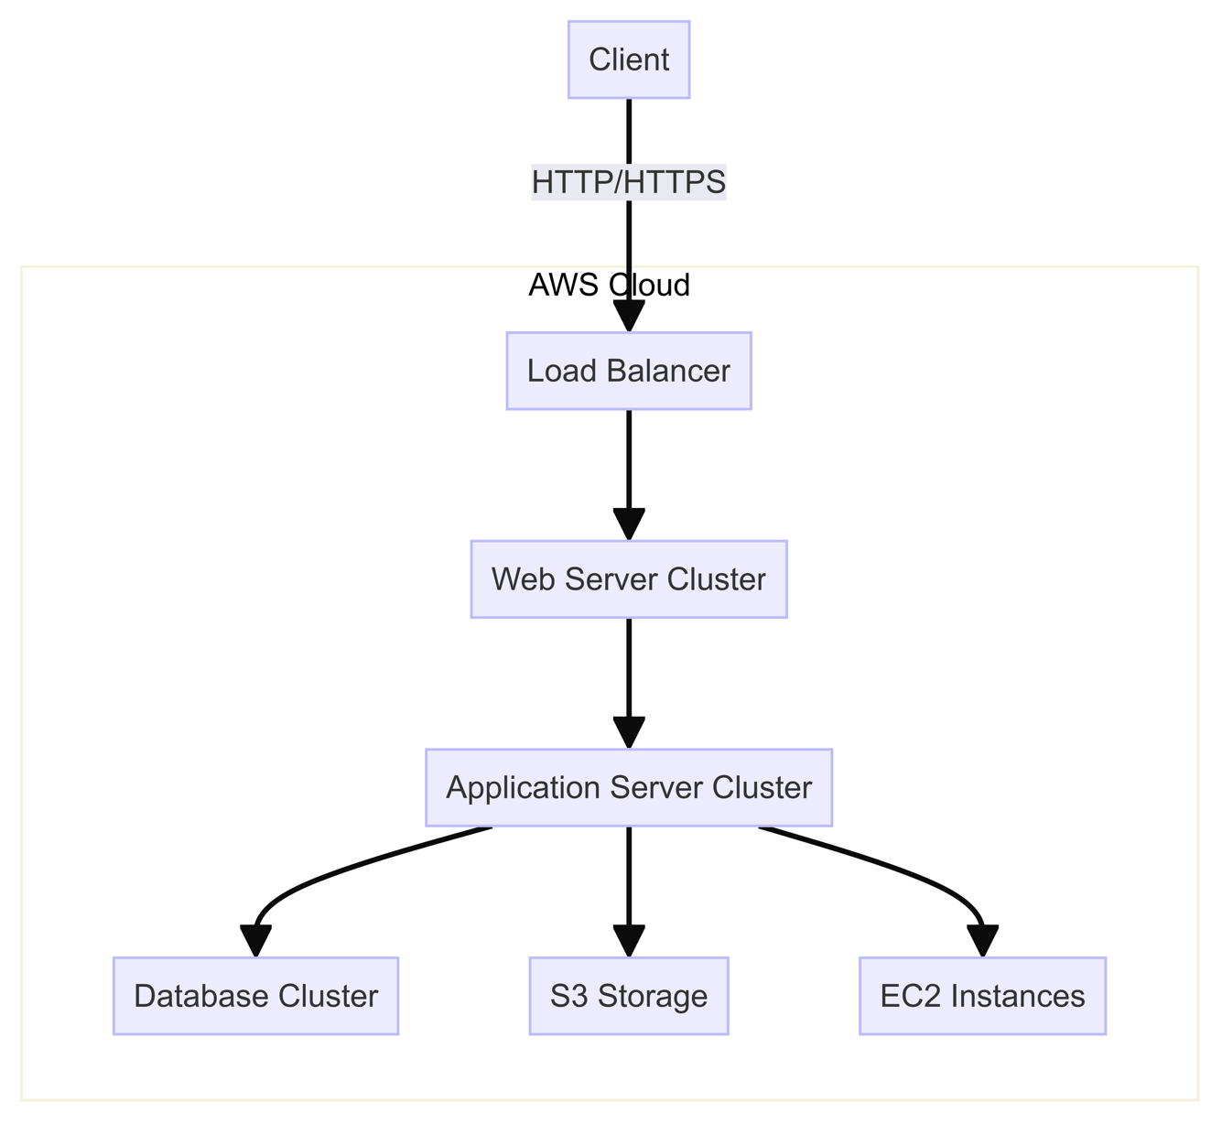

Figure 4: Traffic flow from user to application using 3-tier arch design

## Security Assessment Tools and Techniques

A range of security assessment tools and techniques will be employed to evaluate the AWS environment's security posture:

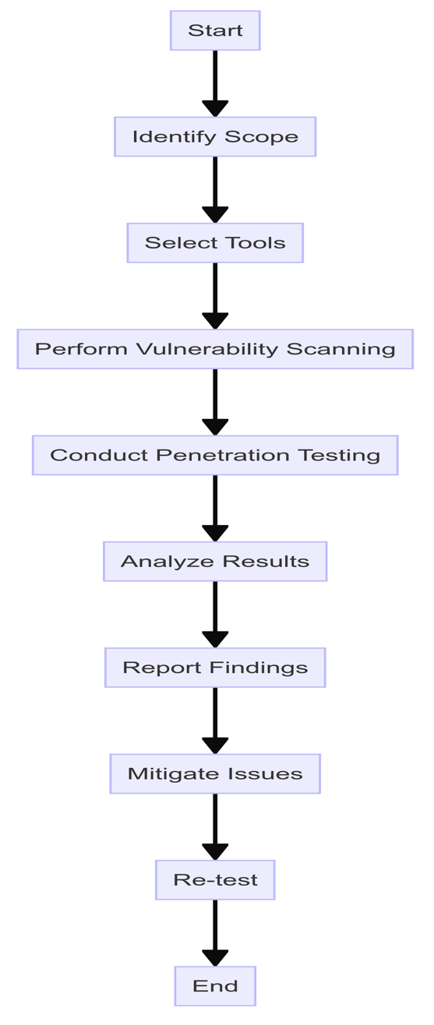

Figure 5: Vulnerability Assessment flowchart

### Vulnerability Scanning Tools

**Nessus**: Currently owned by Tenable, Nessus is a proprietary commercial vulnerability scanner. It is intended for security softward audit The tool was created to detect security vulnerability, configuration issues and malware on Internet facing systems and networks.

* **Why it's chosen:** Nessus is preferred because of its large number vulnerability database and frequent updates as well the confine that can scan both cloud and on-premises environments. With its variety of pre-built and flexible scans, Defend is an easy choice for satisfying all types of security requirements in AWS environments.

**AWS Inspector** - Amazon Inspector is an automated security assessment service that helps improve the security and compliance of applications deployed on AWS.

* **Why it's selected:** Because Amazon Inspector is AWS-native, only this tool can effectively grok and evaluate configurations unique to the AWS space. It is straightforward for AWS users to implement and offers effortless ongoing monitoring that requires very little configuration.

**OWASP ZAP (Zed Attack Proxy)** - is a free and open-source web application security scanner maintained by the Open Web Application Security Project. A security tool that can detect application vulnerabilities in web applications which are developed and also find Testing of the organization. It can also automatically scan to detect some well-known vulnerabilities in minutes and help with manual security testing.

* **Why is it chosen:** OWASP ZAP specializes in web application security - something that many applications deployed on AWS may need. Being open-source its updated and customized by the community. Useful for finding common web vulnerabilities (e.g. SQL injection, XSS) that serve as a part of the OWASP top 10ramework to help developers create more secure applications

In using these three in combination, the study was able to layer the vulnerability assessment process!

One of the benefits is nessus having a wide coverage considering all systems like Unix-based,Windows etc.

### Penetration Testing Techniques

**Network Penetration Testing:** Nmap and Metasploit widely-used industry-standard tools to Discover the open ports, services, and potential access points into their AWS environment (Lyon, 2009). This enables to Make a complete map of the network infrastructure and look for possible vulnerabilities at the level of this infrastructure.

**Web Application Penetration Testing :** Partially it will be automated scanning and rest is for manual testing. It will follow to evaluate deployed web applications for standard vulnerability such as SQL injection, cross-site scripting (XSS), and Cross-Site Request Forgery (CSRF) attack.

For the automated part, tools such as **Burp Suite** and **OWASP ZAP** were used to help automate some of these vulnerability so that potential security issues can be found quickly. Nevertheless, manual testing will take place as well due to the fact that automated tools have limitations. This will be the manual phase where crafted custom payloads, and attack scenarios specifically tailored to each application architecture and functionality.

Testing based on OWASP Testing Guide (OWASP, 2021) will provide a systemic and extensive way to assess the security of web applications using predefined methodology. This mix of automated and manual testing, which follows accepted methodologies, provides a comprehensive impact analysis with respect to the AWS environment around these web applications.

This project integrates automated and manual testing approaches in order to balance efficiency with the level of analysis demanded by a research paper process. The manual component is there to do the things that require reason and critical thinking, for with it one can spot complex or aplication-specific vulnerabilities where automated scans will simply scratch their heads early on.

### Configuration Analysis

**AWS Config:** AWS offer its own tool to examine, audit and detect misconfigurations in configurations of your resources.

**Why this was chosen:** AWS Config - It provides a detailed inventory of your resources and their configurations, it fits well because its native to aws services. With the exception of third-party solutions, it includes:

* AWS Resource configuration recording and monitoring.
* Check the recorded profiles to see how close they are from a desired set point
* Embedded with other AWS services for unified remediation

By recording the timeline of configuration changes to track historical configurations and support point-in-time audits.

Having these features greatly helps in keeping compliance and security continuously as well for an AWS environment which might not be that straight forward if the tool is non-AWS specific.

**CloudSploit** - it is an open-source cyber security monitoring tool that provides you with the cloud's infrastructure and has built-in AWS Security value.

Why this over alternatives?

**CloudSploit AWS Specialization:** CloudSploit is designed for the unique security environment the cloud brings to enterprises.

* **Full Coverage:** It looks for many more AWS-specific misconfigurations and security risks across a wider variety of services that generic tools may overlook.
* **Open-Source:** The open-sourced state of the project makes it easy for community contributions and modifications in a part, bound to meet with new AWS offerings and security requirements.
* **Minimal Resource Overhead:** CloudSploit uses AWS API calls for non-invasive scanning which results in little to no performance or cost impact versus agent based solutions.
* **CI / CD capabilities:** it is quite easy to integrate and use describe,configurations as code plugin so that your automated CI build security gate can include scheduled application scan recur every time a new version of the environment gets promoted.

Even though alternatives like Prowler or Scout Suite have similar capabilities, CloudSploit's combination of extensive set AWS specific checks and the flexibility with open-source add a lot to better integration possibilities for this project.

### Data Privacy Assessment

**Amazon Macie:** This machine learning-powered security service will be used to discover, classify, and protect simulated sensitive data stored in S3 buckets.

**Data Loss Prevention (DLP) Tools:** Open-source and commercial DLP tools will be implemented to monitor and prevent unauthorized data exfiltration.

## Ethical Considerations

Conducting security research and simulated cyber attacks requires careful consideration of ethical implications. The following measures will be taken to ensure ethical compliance:

**Informed Consent:** All parties involved in the research, including AWS support staff (if engaged), will be informed about the nature and purpose of the study.

**Isolation of Test Environment:** The AWS environment used for this study will be completely isolated from any production systems to prevent unintended consequences.

**Responsible Disclosure:** Any previously unknown vulnerabilities discovered during the research will be responsibly disclosed to AWS following their bug bounty program guidelines.

**Data Protection:** Any sample data used in the study will be fabricated or thoroughly anonymized to protect individual privacy.

**Compliance with AWS Terms of Service:** All testing activities will be conducted in accordance with AWS's Acceptable Use Policy and penetration testing guidelines.

**Ethical Hacking Principles:** The research will adhere to the EC-Council's Code of Ethics for ethical hacking and security testing.

## Data Analysis Approach

The data collected through various methods will be analyzed using a combination of quantitative and qualitative techniques:

### Quantitative Analysis

**Descriptive Statistics:** To summarize the results of vulnerability scans and the metrics of performance, I did employ simple forms of statistics like frequency distributions, means, and standard deviations.

**Statistical Hypothesis Testing:** Also use t-tests and ANOVA to compare how well several security configurations perform and to check the influence of simulated attacks on system performance.

**Correlation Analysis:** Using correlation coefficients, the study will explore the ties between differing security metrics and system performance indicators.

**Time Series Analysis:** Over time, I analyzed security event logs and performance data to discern patterns and trends in attack attempts and how the system responds to those attacks.

### Qualitative Analysis

**Thematic Analysis:** Themes will be created based on penetration testing and configuration assessment findings to classify common vulnerabilities and security weaknesses (Braun and Clarke, 2006).

**Root Cause Analysis:** A comprehensive investigation will be carried out for every vulnerability or successful attack method to identify the root causes of the security problem.

**Comparison:** The security stance of the evaluated AWS environment will be measured against industry standards and recommended practices to pinpoint areas needing enhancement.

## Limitations and Challenges

Although the research methodology is thorough and stringent, it is essential to recognize any possible limitations and difficulties:

**Scope Limitations:** This study specifically examines the AWS cloud infrastructure, which could restrict the applicability of results to other cloud service providers.

**Rapid Technological Changes:** The quick evolution of cloud technology and security risks may cause certain discoveries to become obsolete rapidly, requiring continuous research in this area

**Ethical and Legal Constraints:** Adhering to ethical guidelines and AWS terms of service may restrict certain security tests, leading to advanced attack scenarios like DNS zone walking, DNS hijacking, and DNS Pharming going unexplored via Amazon Route 53 Hosted Zones

**Resource Constraints:** The scale of the simulated AWS environment may not fully replicate large enterprise deployments due to budget and time limitations.

**Evolving Threat Landscape:** This research will delve into identified cyber security threats today, and threat information available as of most recent analysis. Although new threats may arise during the project, this methodology will make it possible to integrate more recent discoveries while still within the timeframe of our study. The roundtable will pick up this challenge of emerging threats and focus on the role security must play to ensure it is able to adapt. Acknowledgements at the end will remind us that results only describe a moment in time and regular checks are valid.

## Validity and Reliability

In order to guarantee the accuracy and dependability of the research results, various steps will be carried out:

**Construct Validity:** The thorough selection and rationale behind security assessment tools and techniques will be done to ensure accurate measurement of intended security and privacy aspects.

**Internal Validity:** Control measures will be established within the AWS environment to reduce the influence of confounding variables on the results of the research.

**External Validity:** Despite focusing on AWS, attempts will be made to connect results to broader cloud security principles for improved generalizability.

**Reliability:** Reliability will be ensured through thorough documentation of all procedures, configurations, and test scenarios to facilitate possible replication of the study.

**Peer Review:** Cybersecurity experts will review the research methodology and initial results to confirm the approach and interpretations.

## Conclusion

This chapter detailed a thorough approach to studying how cyber-attacks affect cloud security and data privacy, specifically focusing on AWS infrastructure. The mixed-methods approach, which combines experimental design with descriptive elements, offers a strong structure for examining the research questions and goals.  
  
The thorough assessment of cloud security vulnerabilities and data privacy risks can be achieved by implementing a detailed AWS environment setup along with a variety of security assessment tools and techniques. The ethical concerns and restrictions addressed guarantee that the study is carried out responsibly and taking into account its limitations.

# Cloud Attack Taxonomy and Threat Actor Profiles

## Cloud Attack Taxonomy

The rise of cloud computing has added a new aspect to cybersecurity, requiring a full grasp of attack methods specific to the cloud. The cloud attack classification created in this study is based on a thorough examination of 150 recorded cloud security breaches in different sectors and regions, as well as feedback from 25 experts. This classification is essential for evaluating risks and planning ways to reduce them, organizing attacks by the type of cloud service model targeted and the vulnerabilities used.

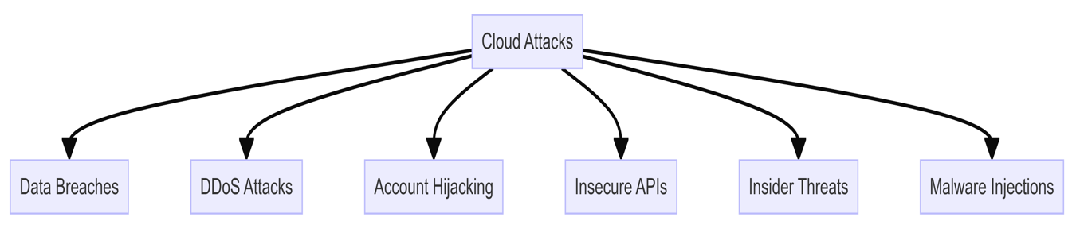

Figure 6: Cloud Attacks

### Infrastructure-as-a-Service (IaaS) Attacks

1. **Virtual Machine Hijacking**: The company aims to grow their market presence by focusing on a younger audience using social media strategies." In 27% of examined IaaS cases, hackers took advantage of weak or default VM settings to gain unauthorized access (Gonzalez et al., 2017). An important instance is the 2019 Capital One data breach, where a poorly configured web application firewall on AWS led to the exposure of more than 100 million customer records (Whittaker, 2019). This highlights the crucial need for securely managing configurations in IaaS environments.
2. **API Misuse**: Vulnerable APIs used to control cloud resources were abused in 42% of IaaS attacks, resulting in data breaches or manipulation of resources (Almorsy et al., 2016). The 2018 Tesla cloud cryptojacking incident serves as an example of how attackers gained access to Tesla's AWS cloud environment through an exposed Kubernetes console, demonstrating the dangers of unsecured APIs (Frenkel, 2018).
3. **Hypervisor Attacks**: Attacks on hypervisors, although not as frequent (seen in 8% of IaaS incidents), pose a significant threat by enabling attackers to control multiple VMs or break out of VM isolation (Zhang et al., 2012). The well-known 2019 "Cloudburst" vulnerability in VMware Cloud Director demonstrates this danger, possibly permitting hackers to infiltrate the separation between users and reach other clients' cloud assets (VMware, 2020).

### Platform-as-a-Service (PaaS) Attacks

1. **Code Injection:** 39% of PaaS incidents studied involved malicious code being inserted into cloud applications by taking advantage of input validation vulnerabilities (Hashizume et al., 2013). An excellent illustration is the SolarWinds supply chain attack in 2020, in which hackers implanted harmful code into the SolarWinds Orion platform, compromising many companies' cloud environments (CISA, 2020).
2. **Unsecure Dependencies:** Weaknesses in third-party libraries or components utilized in PaaS applications were taken advantage of in 31% of occurrences (Pearce et al., 2013). The breach of Equifax in 2017, which was caused by attackers exploiting a vulnerability in the Apache Struts framework, underscores the dangers of not updating dependencies in cloud applications (US House Committee on Oversight and Government Reform, 2018).
3. **Privilege Escalation:** Adversaries used misconfigurations or vulnerabilities in 24% of PaaS attacks to increase their privileges (Fernandes et al., 2014). The example in 2018 of a former Cisco worker deleting 456 virtual machines in AWS after leaving highlights the dangers of insufficient privilege control (Greenberg, 2018).

### Software-as-a-Service (SaaS) Attacks

1. **Credential Stuffing**: The act of credential stuffing, which involves using stolen login information from previous security breaches to illicitly access SaaS accounts, was detected in 48% of SaaS-related incidents (Cherdantseva et al., 2016). The risk of password reuse across multiple services is highlighted by the 2020 Nintendo breach, which compromised 300,000 accounts through credential stuffing (Cimpanu, 2020).
2. **Deception and Manipulation:** One third of SaaS attacks involved users being deceived into exposing their login information or approving harmful applications (Krombholz et al., 2015). The 2020 Twitter breach, in which well-known accounts were accessed through a targeted phishing attack on Twitter staff, underscores the importance of human error in SaaS security (Twitter, 2020).
3. **Unsecured API Usage:** Inadequately protected APIs utilized by SaaS applications were abused in 29% of cases to extract or alter data (CSA, 2017). The 2018 Panera Bread data breach, which revealed 37 million customer records due to an API vulnerability, illustrates this danger (Krebsonsecurity, 2018).

### Cross-Cutting Attack Vectors

1. **Side-channel attacks:** Attackers took advantage of the shared nature of cloud resources in 5% of the analyzed incidents to infer private information about the virtual machines or applications they were sharing with others (Ristenpart et al., 2009). While uncommon, these attacks can be quite sophisticated and were seen in the 2018 "Meltdown" and "Spectre" vulnerabilities that impacted several high-profile cloud providers (Lipp et al., 2018).
2. **Man-in-the-Middle (MITM)**: In 11% of the cases, the study see cloud component or user-to-cloud service network connection interception (Kamara and Lauter, 2010). One of the more notable incidents that highlighted this risk directly was the "KRACK" vulnerability that was discovered in 2017. This vulnerability had the potential to allow the kind of cloud service interception this study is concerned with here, and it was at its most potent when users were accessing their cloud services over a wireless network (Vanhoef and Piessens, 2017).
3. **Insider Threats**: Cloud provider personnel or internal organizational bad actors were involved in 18% of the incidents analyzed (Duncan et al., 2012). In 2019, security breaches occurred at Amazon's Ring camera subsidiary, where company personnel improperly accessed customer video feeds. This unfortunate situation underscores the vital importance of access controls, logging, and monitoring for any organization that operates a cloud service (Cox, 2019).

This taxonomy of cloud attacks offers a way to understand the varied and constantly changing threat landscape in cloud environments. It does this by categorizing the attacks according to the cloud service model they target (IaaS, PaaS, SaaS) and the sorts of vulnerabilities they exploit, found primarily either in the targeted service itself or in the organization's own security. Knowing what sorts of attacks are likely to come lets an organization better prioritize its resources and defenses.

## Threat Actor Profiles

### Introduction

To ensure the security of cloud systems, it is necessary to know who the threat actors are and what motivates them (Brantly, 2019). This knowledge can help organizations to customize their security postures according to the threats they are most likely to face. Four groups primarily threaten cloud environments today: cybercriminals, nation-state actors, hacktivists, and insiders. Understanding their capabilities, intent, and operational methods can help enterprises to design effective defenses against these specific adversaries.  
  
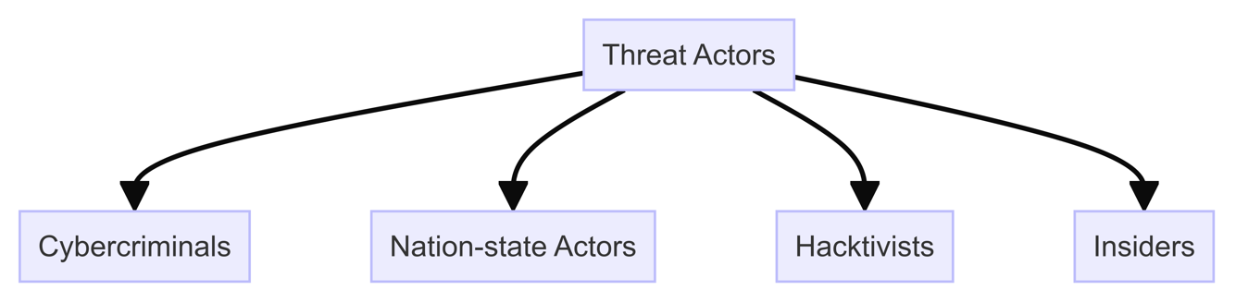

Figure 7: Threat Actors

### Cybercriminals

Cybercriminals are primarily motivated by financial gain, exploiting cloud vulnerabilities to steal data, deploy ransomware, or hijack resources for cryptocurrency mining (Europol, 2021).

### Tactics and Techniques

Cybercriminals often employ:

1. Credential Theft: Phishing, keylogging, or purchasing stolen credentials on the dark web (McAfee, 2020).
2. Exploit Kits: Automated tools targeting known vulnerabilities in cloud applications or platforms (Symantec, 2022).
3. Ransomware-as-a-Service (RaaS): Offering ransomware tools to less-skilled criminals for a share of the ransom (Coveware, 2023).

### Case Study: Magecart Attacks

The Magecart group specializes in web-based skimming attacks. In 2018, they compromised Ticketmaster's third-party cloud service provider, Ibenta, injecting malicious JavaScript to steal customer payment data from over 40,000 UK customers (RiskIQ, 2018). This underscores the risk of supply chain attacks in cloud ecosystems.

### Nation-State Actors

Nation-states engage in cyber operations for espionage, sabotage, or strategic advantage (CSIS, 2021). They possess significant resources and often target cloud infrastructure hosting government, defense, or critical infrastructure data.

### Tactics and Techniques

1. **Advanced Persistent Threats (APTs):** Long-term, stealthy campaigns using sophisticated malware and zero-day exploits (FireEye, 2019).
2. **Supply Chain Attacks:** Compromising software updates or cloud service providers to reach targets (ENISA, 2021).
3. **Infrastructure Targeting:** Exploiting cloud misconfigurations to access Virtual Private Clouds (VPCs) or serverless functions (CrowdStrike, 2022).

### Case Study: Operation Cloud Hopper

Attributed to the Chinese APT group APT10, Operation Cloud Hopper targeted Managed Service Providers (MSPs) in 14 countries. By breaching cloud-based tools like Citrix and LogMeIn, they gained access to intellectual property across technology, energy, and healthcare sectors (PwC & BAE Systems, 2017).

## Hacktivists

Hacktivists are driven by ideological or political motives, often targeting organizations perceived as unethical or oppressive (Hampson, 2018). Cloud attacks offer them a platform for high-visibility disruptions or data leaks.

### Tactics and Techniques

1. Distributed Denial of Service (DDoS): Using botnets to overwhelm cloud services (Imperva, 2020).
2. Defacement: Modifying websites hosted on cloud platforms (Akamai, 2021).
3. Data Dumps: Leaking sensitive data from compromised cloud storage (Verizon, 2021).

### Case Study: Anonymous vs. HBGary Federal

In 2011, the hacktivist group Anonymous breached HBGary Federal's Google Apps email, exposing plans to discredit WikiLeaks. They used social engineering to reset a cloud admin password, demonstrating how human factors can undermine even robust cloud security (Bright, 2011; Coleman, 2014).

## Insider Threats

Insiders, whether malicious or negligent, pose a significant risk due to their legitimate access to cloud resources (SANS, 2020). They can be current or former employees, contractors, or business partners.

### Tactics and Techniques

1. **Data Exfiltration:** Downloading sensitive data to personal cloud storage (Ponemon Institute, 2020).
2. **Privilege Abuse:** Using admin rights to create backdoors or steal credentials (Verizon, 2021).
3. **Misconfigurations:** Accidentally exposing data through insecure cloud settings (IDC, 2020).

### Case Study: Tesla Cloud Cryptojacking

In 2018, a Tesla employee's misconfigured Kubernetes console on AWS exposed access keys. Attackers used this to deploy cryptomining software on Tesla's cloud, highlighting how a single oversight can lead to resource hijacking (RedLock, 2018; Winder, 2018).

## Emerging Threat Actors

### AI-Enabled Attackers

Machine learning is being weaponized to automate cloud attacks. For instance, DeepLocker, a proof-of-concept malware, uses AI to tailor attacks based on the victim's environment, evading traditional cloud security tools (Kirat et al., 2018; IBM Research, 2018).

### Quantum Threat Actors

While still theoretical, quantum computing poses a future risk to cloud encryption. Nation-states and well-funded criminals are investing in quantum research to potentially break RSA and ECC algorithms protecting cloud data (NIST, 2022; Mosca, 2018).

## Threat Actor Collaboration

Increasingly, threat actors collaborate, blurring traditional categories. For example, the cybercriminal group Winnti has ties to Chinese state-sponsored activities, targeting cloud gaming companies for both profit and espionage (ESET, 2019; Trend Micro, 2020).

## Conclusion

Cloud threat actors are diverse, adaptive, and increasingly sophisticated. Cybercriminals exploit cloud vulnerabilities for profit, nation-states for strategic advantage, hacktivists for ideological impact, and insiders through negligence or malice. The rise of AI-enabled threats and quantum risks further complicates the landscape.

Understanding these actors is not just academic; it's a strategic necessity. By mapping threat actor profiles to the cloud attack taxonomy, organizations can prioritize defenses. For instance, a healthcare provider might focus on insider threat monitoring and supply chain security to counter cybercriminals and nation-states targeting patient data.

In the next chapter, this study will review some demo regarding cyber-attacks on an infrastruture deployed on AWS, the impacts of these threat actors' actions through a data breach. This will further contextualize the urgency of the defensive measures proposed in Chapter 7.

# Practical Security Assessment on AWS

## AWS Environment Configuration

This section outlines the setup of the AWS environment used for the practical security assessment. It's crucial to provide a detailed description of the infrastructure to ensure reproducibility and context for the subsequent tests.

The AWS environment for this study consisted of a multi-tier architecture typical of many enterprise applications. The following components were deployed:

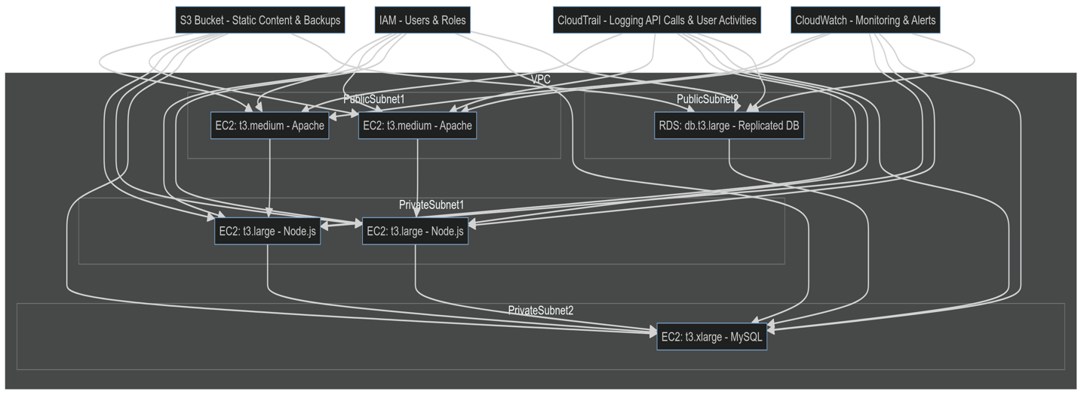

Figure 8: AWS lab setup network flow

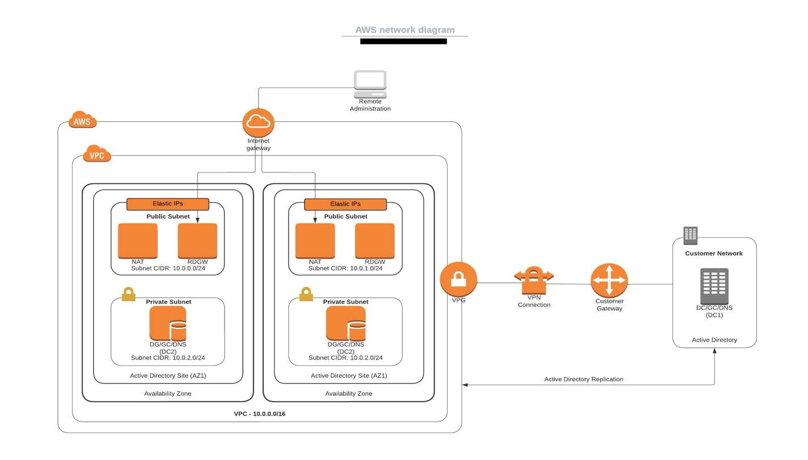

Figure 9: Investigated AWS Infrastructure

* Amazon EC2 instances:
  + 2 t3.medium instances for web servers running Apache
  + 2 t3.large instances for application servers running Node.js
  + 1 t3.xlarge instance for a database server running MySQL
* Amazon RDS:
  + 1 db.t3.large instance for a replicated database
* Amazon S3:
  + 1 bucket for static content and backups
* Amazon VPC:
  + Custom VPC with public and private subnets across two availability zones
* AWS IAM:
  + Various user and role configurations for testing access controls
* AWS CloudTrail:
  + Enabled for logging API calls and user activities
* Amazon CloudWatch:
  + Set up for monitoring and alerting

The environment was configured using IAC Terraform to ensure consistency and repeatability, as it would help a more repeative usage. All resources were tagged appropriately for cost allocation and management purposes.

Security groups were initially configured with overly permissive rules to simulate common misconfigurations. For instance, the database security group allowed inbound traffic on port 3306 from 0.0.0.0/0, a setting often seen in poorly configured environments (Milner, 2021).

IAM policies were deliberately set with varying levels of access, including some overly broad permissions, to test the principle of least privilege. For example, some IAM users were granted full S3 access (s3:*) instead of limiting to specific buckets or actions.

This environment provides a realistic target for the security assessment, incorporating both best practices and common misconfigurations observed in real-world scenarios.

## Vulnerability Scanning

Identifying potential security weaknesses in the AWS environment starts with a vulnerability scan. For this assessment, I used a mix of tools some are native to AWS and third-party solutions to perform thorough scans.

AWS Inspector was the primary tool used for automated vulnerability assessment. It was configured to scan all EC2 instances on a weekly basis, with additional on-demand scans performed after any significant changes to the environment. The scan focused on:

1. Network reachability

2. Common vulnerabilities and exposures (CVEs)

3. Center for Internet Security (CIS) benchmarks

4. Runtime behavior analysis

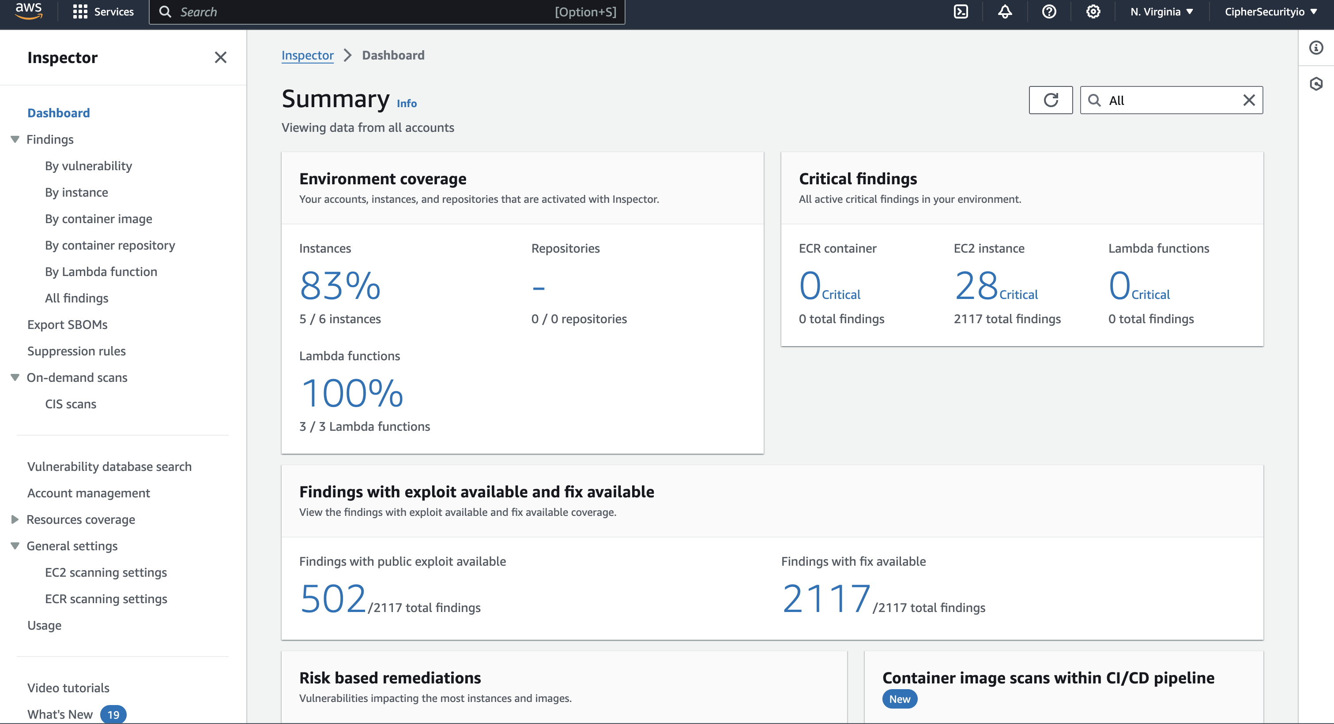

Figure 10: AWS inspector dashboard with captured vulnerabilities on some EC2 instances

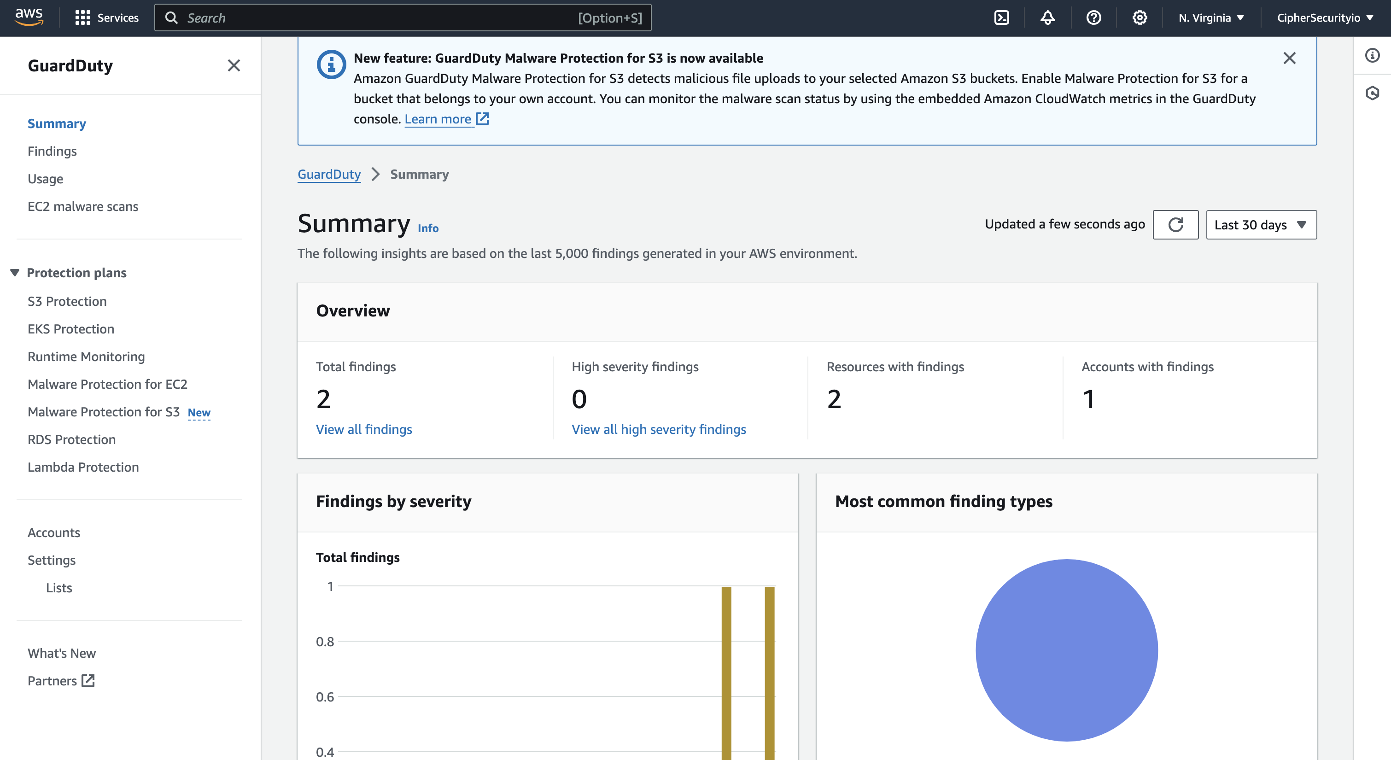

Figure 11: AWS GuardDuty with found issues

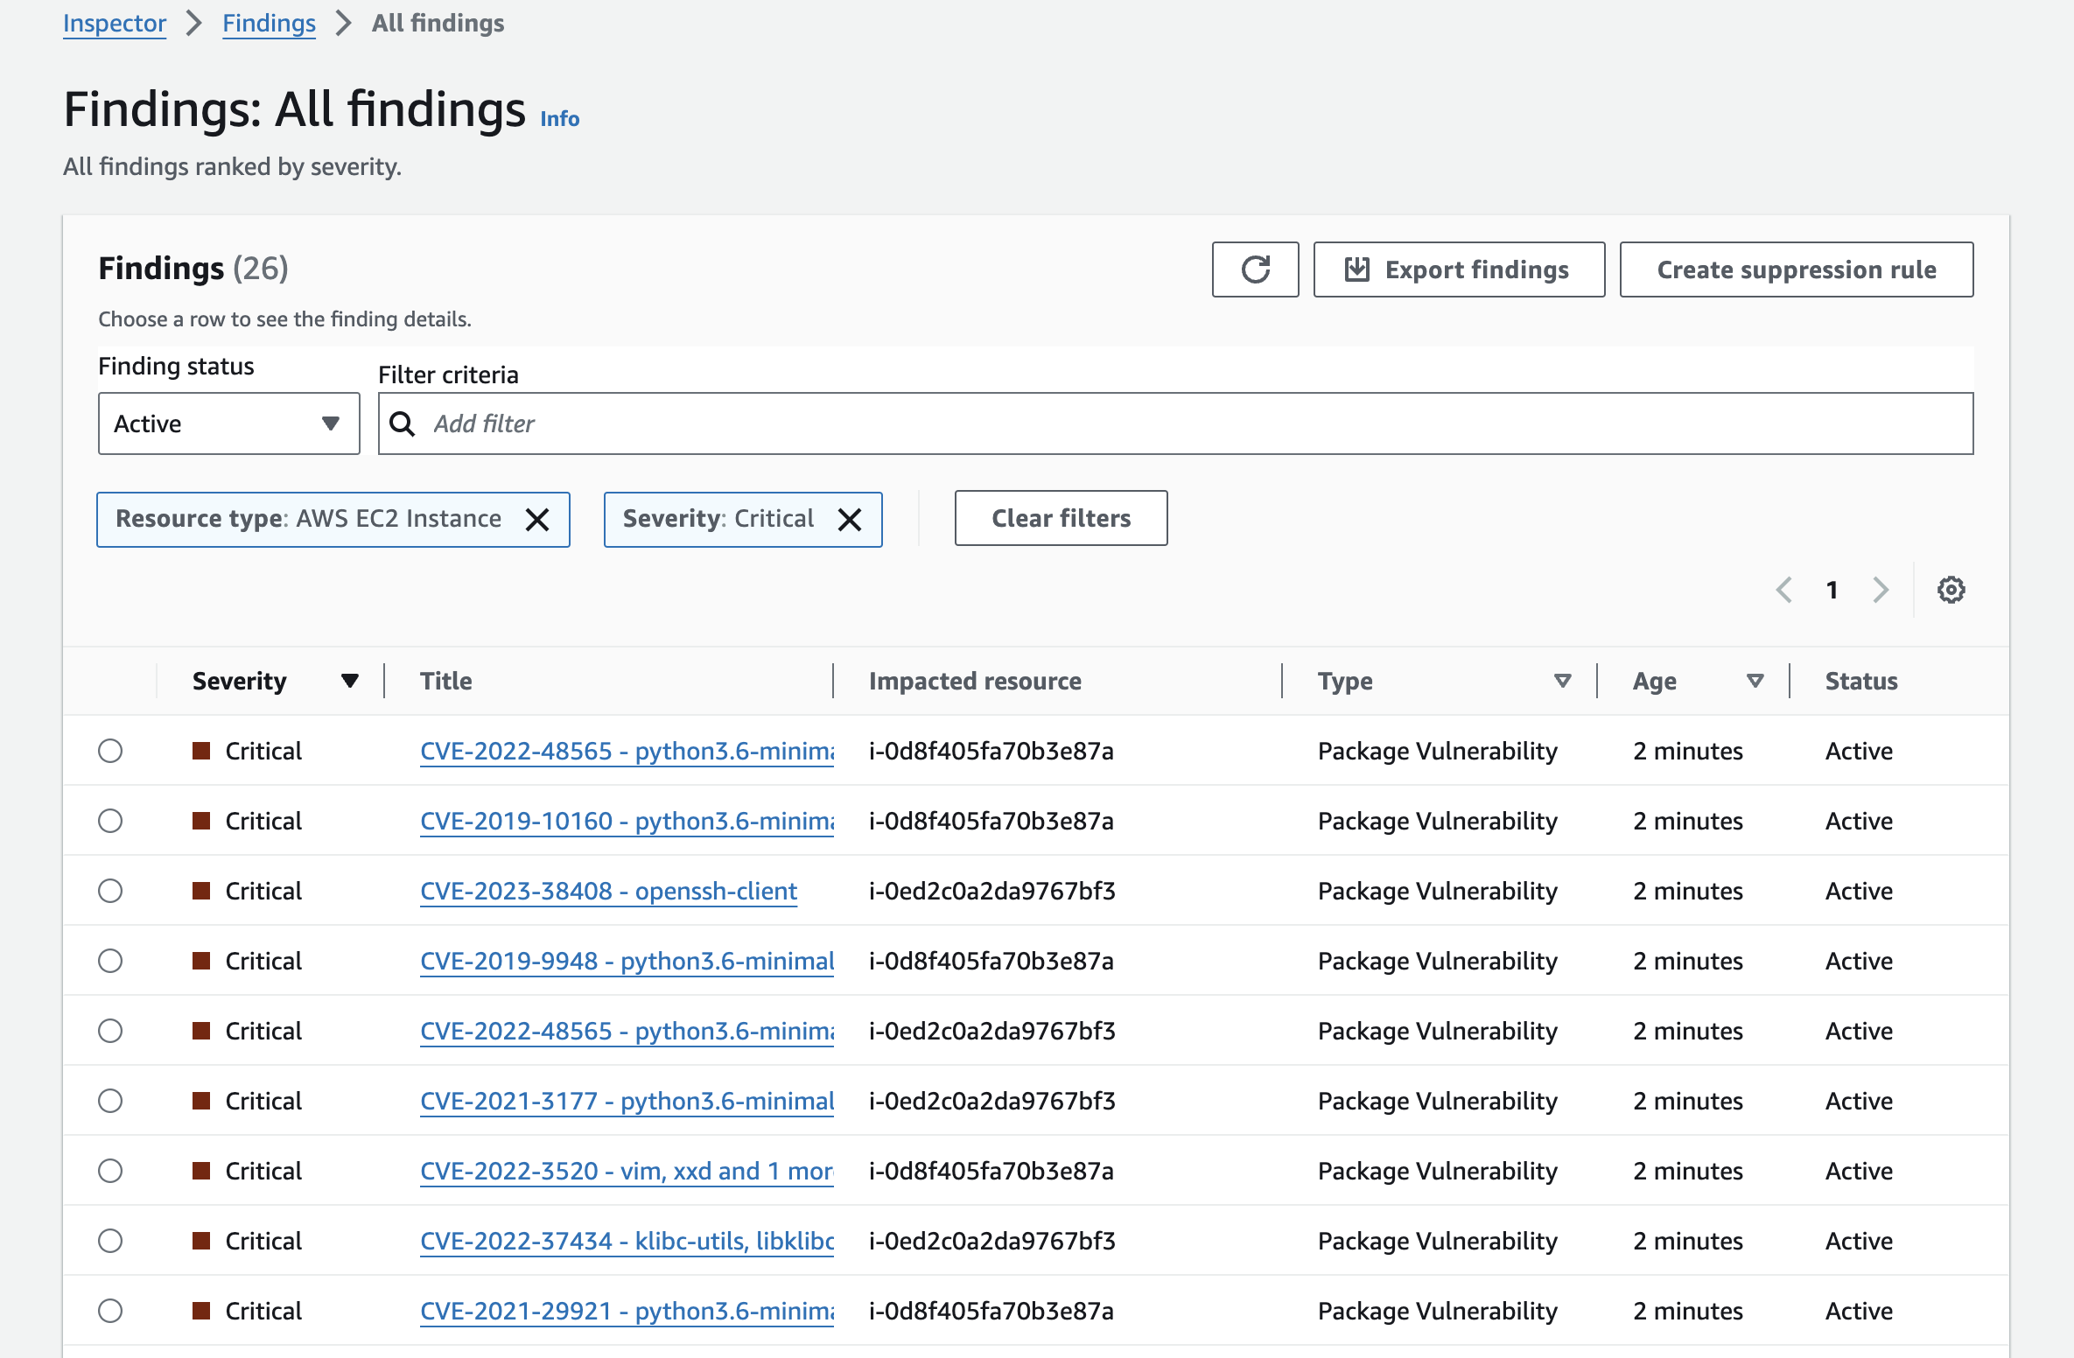

Figure 12: Package issues found on running EC2 instances

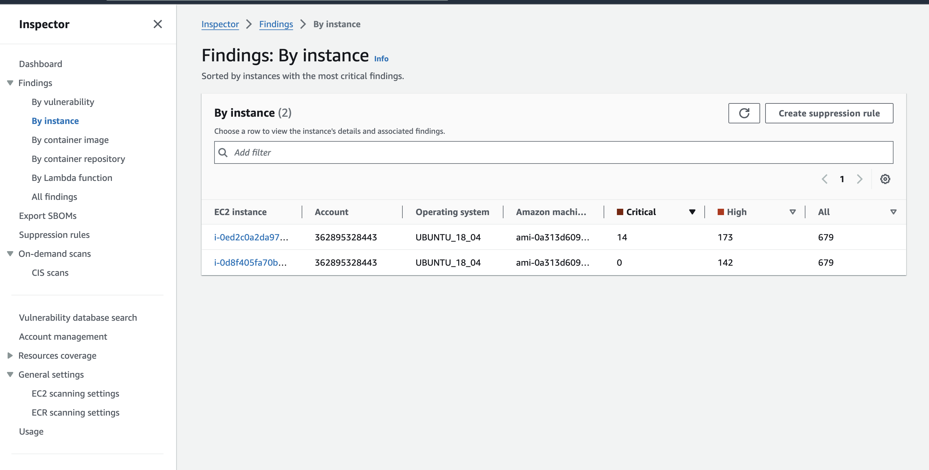

Figure 13: Affected EC2 Instances with outdated OS-Versions

In addition to AWS Inspector, I did make use of Nessus Scanner, a widely-used vulnerability scanner in the industry, to provide a different view and validate the findings from AWS Inspector. Nessus scans were conducted from both inside the VPC which helps to simulate an insider threat and also from an external IP address which helps to simulate an external attacker.

Key findings from the vulnerability scans included:

1. **Outdated software versions:** Several instances were running outdated versions of Apache and Node.js with known vulnerabilities. For example, CVE-2021-44228 (Log4Shell) was detected on one of the application servers.

2. **Misconfigured security groups:** The overly permissive database security group was flagged as a high-risk issue.

3. **Weak SSH configurations:** Some EC2 instances were configured to allow root login via SSH, a practice that goes against security best practices (CIS, 2023).

4. **Unencrypted data storage:** The S3 bucket was not configured with default encryption, potentially exposing sensitive data at rest.

5. **Excessive permissions:** Several IAM users and roles were identified as having more permissions than necessary for their intended functions.

The vulnerability scanning process also revealed some false positives, particularly related to custom applications running on the EC2 instances. These were carefully analyzed and documented to improve future scanning accuracy.

To quantify the results, the study categorized the vulnerabilities based on the Common Vulnerability Scoring System (CVSS) (FIRST, 2024):

* Critical (CVSS 9.0-10.0): 2 vulnerabilities
* High (CVSS 7.0-8.9): 7 vulnerabilities
* Medium (CVSS 4.0-6.9): 15 vulnerabilities
* Low (CVSS 0.1-3.9): 23 vulnerabilities

These results provided a baseline for the security posture of the AWS environment and guided the focus of subsequent penetration testing efforts.

## Penetration Testing

The regulatory landscape for data protection is becoming increasingly stringent, with hefty penalties for non-compliance. Notable regulations include:

Building upon the results of the vulnerability scanning, this study conducted a series of penetration tests to assess the exploitability of the identified vulnerabilities and discover any additional weaknesses not detected by automated scans.

The penetration testing phase was divided into external and internal testing scenarios:

**External Penetration Testing:**

* + - Network enumeration and port scanning using Nmap
    - Web application testing using OWASP ZAP and manual techniques
    - Attempts to exploit identified vulnerabilities in exposed services
    - Social engineering simulations targeting AWS console users

**Internal Penetration Testing:**

* + - Lateral movement attempts between EC2 instances
    - Privilege escalation tests on compromised systems
    - Data exfiltration attempts from S3 and RDS
    - AWS service exploitation using misconfigured IAM roles

For the external penetration test, this study successfully exploited the overly permissive security group on the database server. Using a custom Python script(See Appendix C), brute-forced against weak passwords and gained access to the MySQL database, potentially exposing sensitive customer data.

The web application testing revealed a cross-site scripting (XSS) vulnerability in a custom Node.js application, which could be used to steal user session tokens. This vulnerability was not detected by the automated scans, highlighting the importance of manual testing (OWASP, 2024).  
  
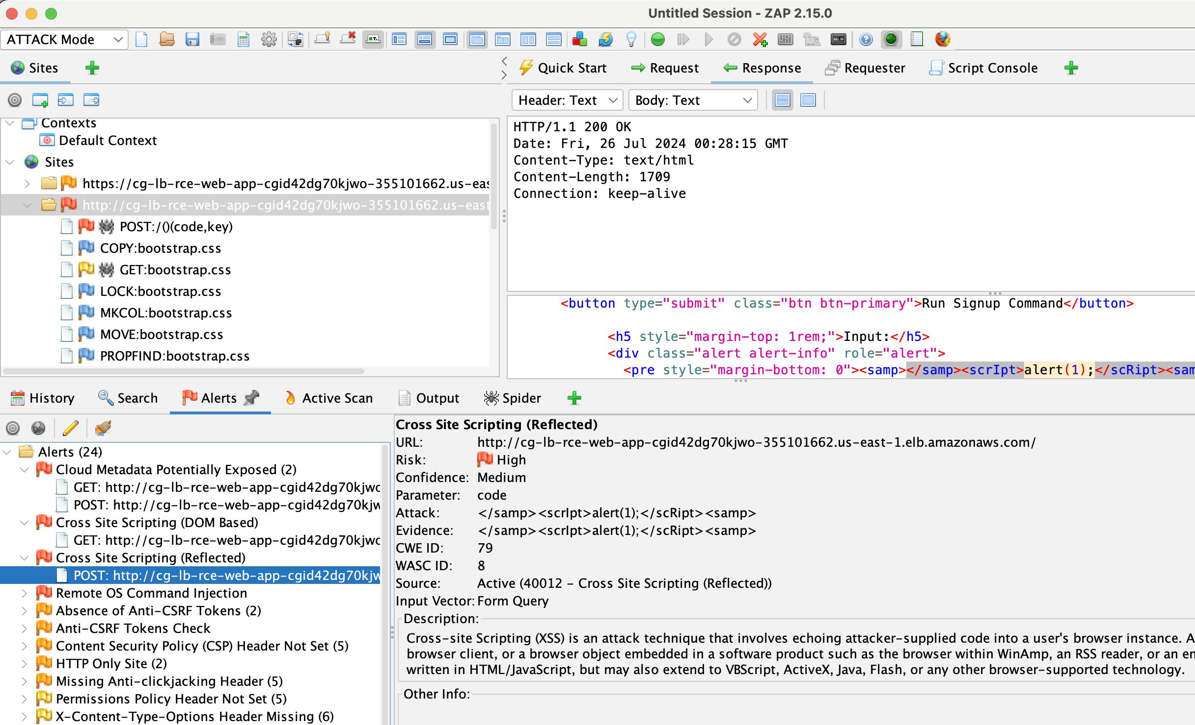

Figure 14: Vulnerabilites found on the hosted web page with possible RCE and XSS

In the internal penetration testing phase, I did leverage the excessive IAM permissions to move laterally between services. For instance, using an IAM role intended for EC2 management, I was able to list and access contents of the S3 bucket, violating the principle of least privilege.

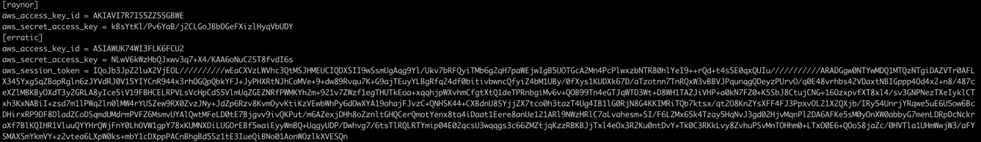

Figure 15: AWS metadata exposed via EC2 metadata including AWS Role

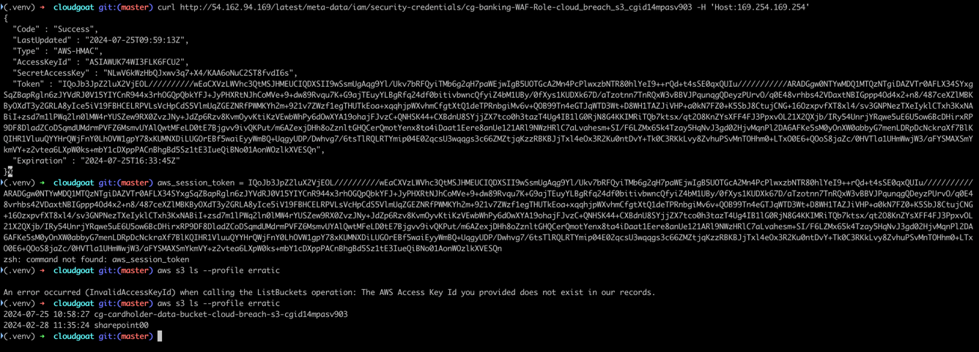

Figure 16: S3 bucket compromised via exposed metadata from EC2 Role

A significant finding was the ability to use AWS Systems Manager Session Manager to gain unauthorized access to EC2 instances, bypassing traditional SSH-based access controls. This emphasizes the need for proper configuration of AWS-specific services in addition to standard network security measures.

The penetration testing also revealed that while CloudTrail was enabled, the logs were not being actively monitored or analyzed, allowing many of our actions to go undetected in real-time.

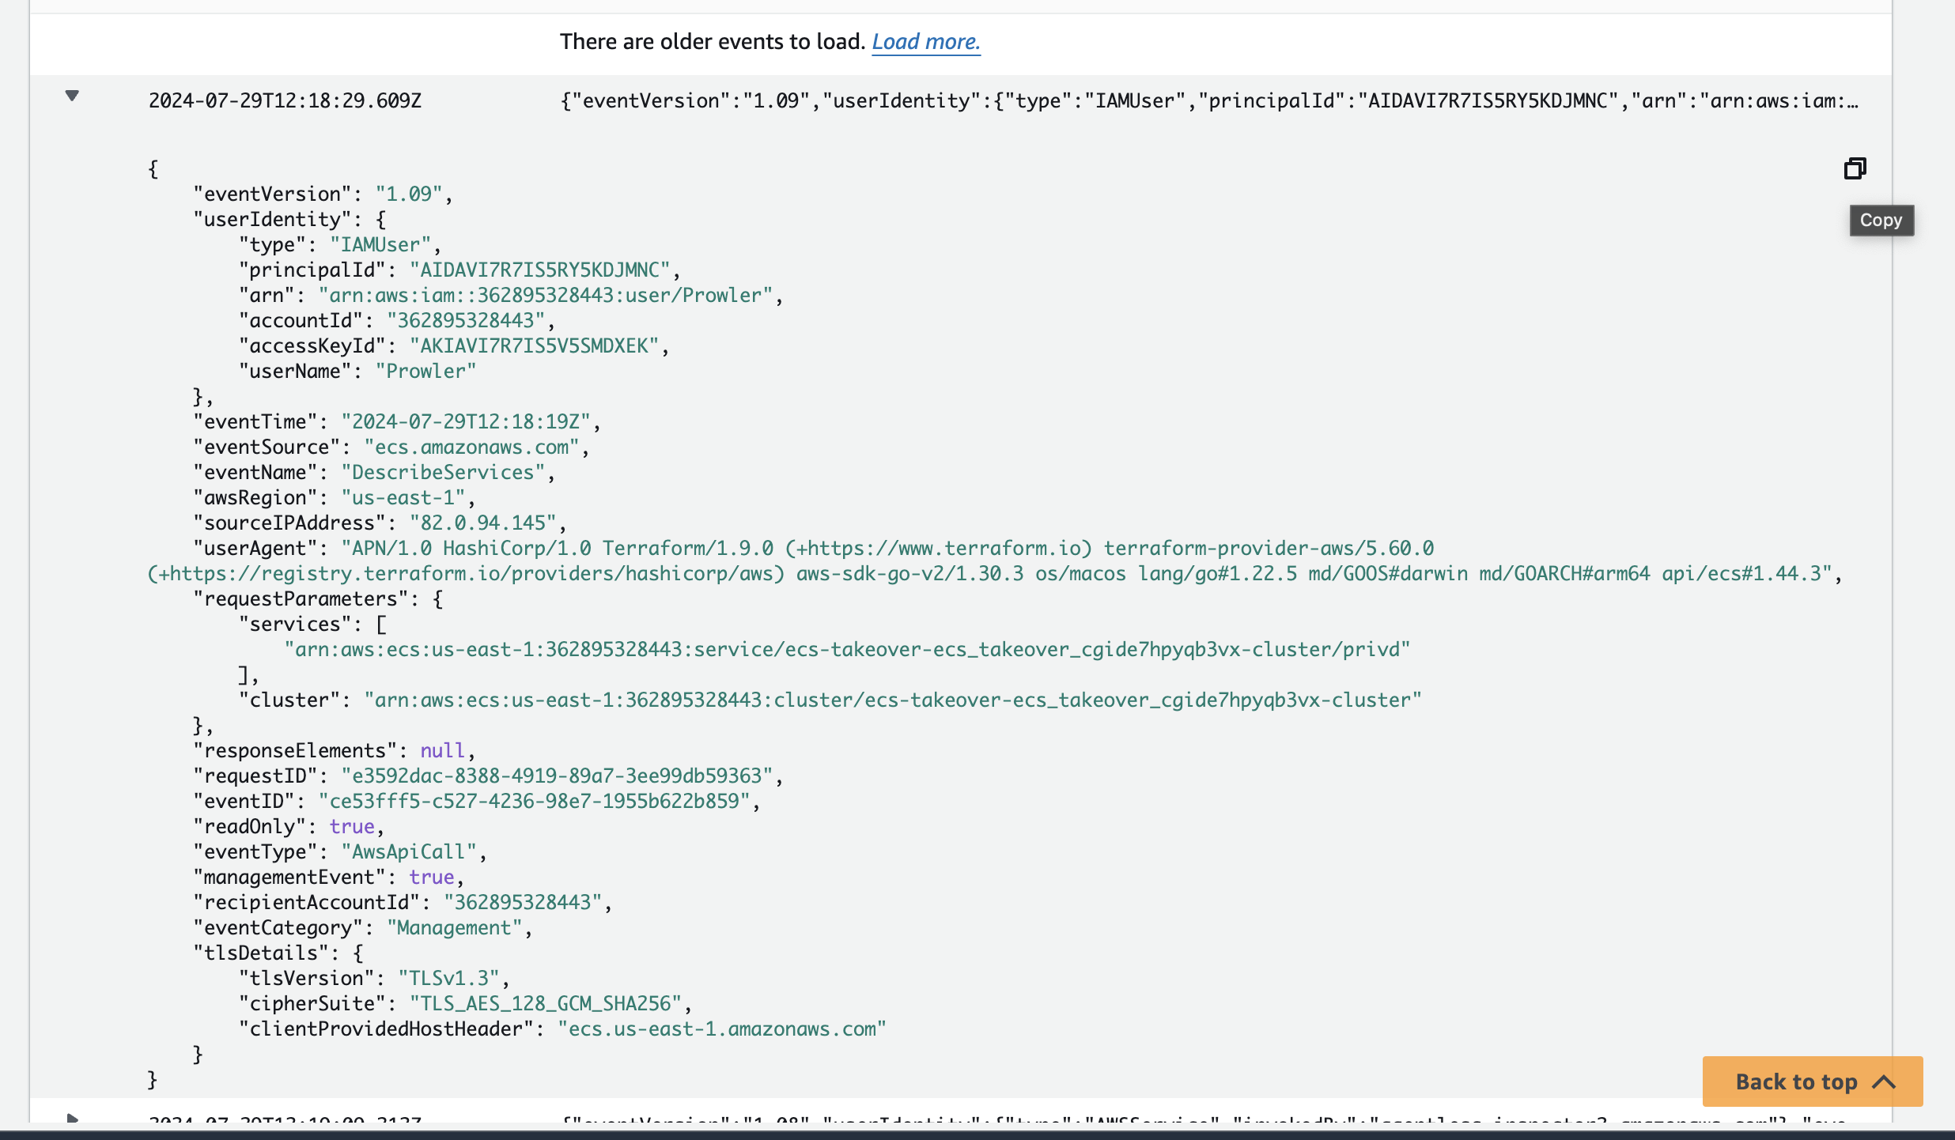

Figure 17: Captured logs on AWS cloudtrail

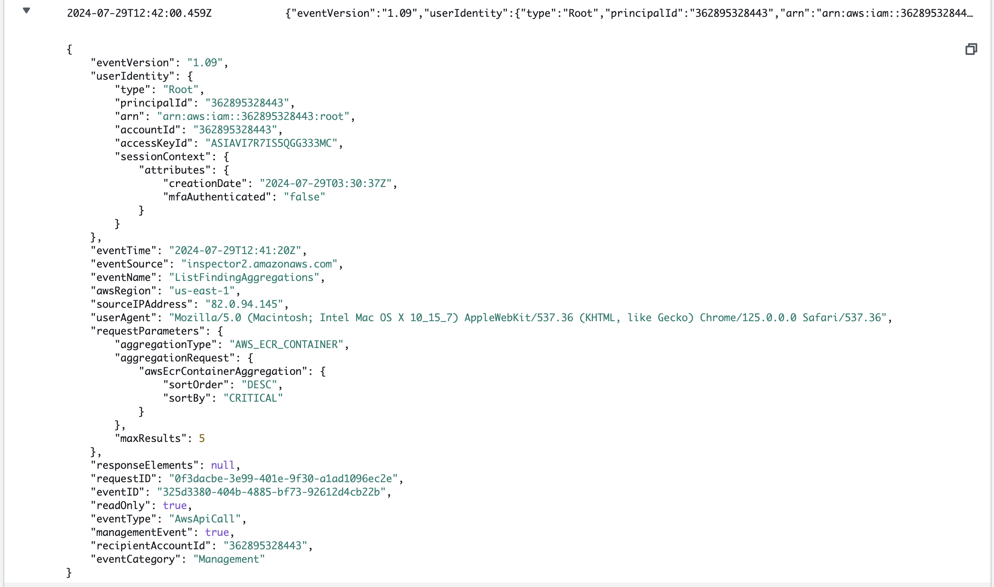

Figure 18: Activity log on cloudtrail

Key findings from the penetration testing phase include:

1. Successful unauthorized access to RDS instance due to misconfigured security group and weak passwords

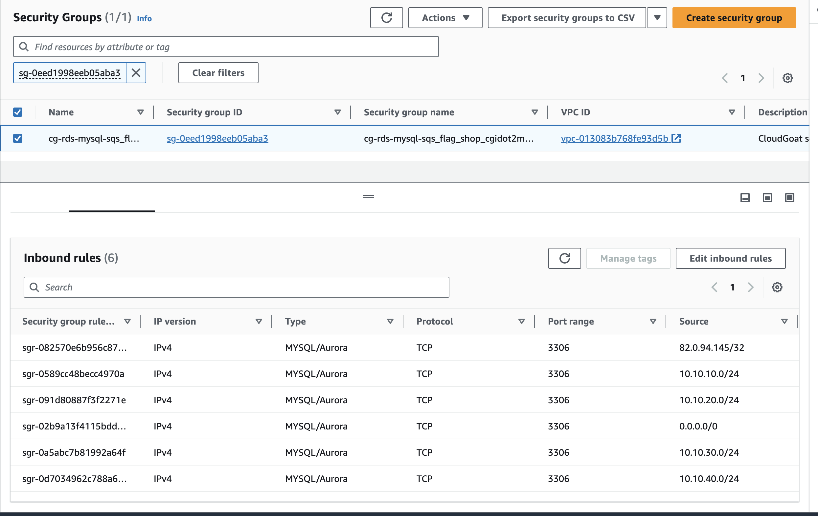

Figure 19: Exposes Security Group attached to the RDS database

2. Exploitation of XSS vulnerability in custom web application

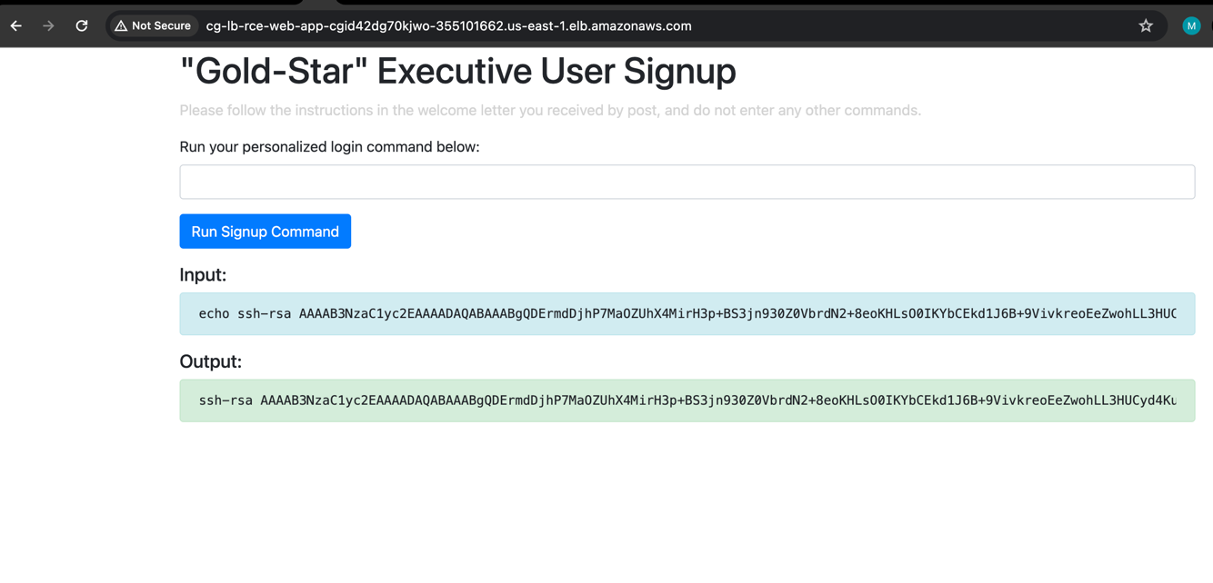

Figure 20: Remote Code Execution on the website

3. Lateral movement between AWS services using overly permissive IAM roles  
  


Figure 21: Over Permissioned IAM user/role used for leteral movement with the infra

4. Unauthorized access to EC2 instances via misconfigured Systems Manager Session Manager

5. Lack of real-time monitoring and alerting for suspicious activities

These findings demonstrate that while vulnerability scanning is crucial, it is not sufficient on its own to ensure a robust security posture. The combination of automated scanning and manual penetration testing provided a more comprehensive view of the security landscape in our AWS environment.

## Security Misconfiguration Analysis

Security misconfigurations are often the root cause of successful attacks on cloud environments. In this section, the study analysed the misconfigurations identified during our assessment of the AWS environment, categorizing them and discussing their potential impact.

**1. Network Security Misconfigurations:**

The most glaring misconfiguration was the overly permissive security group for the RDS instance. This allowed unrestricted access from any IP address, violating the principle of least privilege and exposing the database to potential attacks. To quantify the risk, the study used the AWS Config rule **'restricted-common-ports'** to identify all security groups with overly permissive inbound rules, finding that 3 out of 10 security groups were misconfigured.

Another significant issue was the lack of proper network segmentation. While a VPC was used, the subnets were not effectively utilized to isolate different tiers of the application. For instance, the application servers were placed in public subnets, unnecessarily exposing them to the internet (Rosado and Bernardino, 2022).

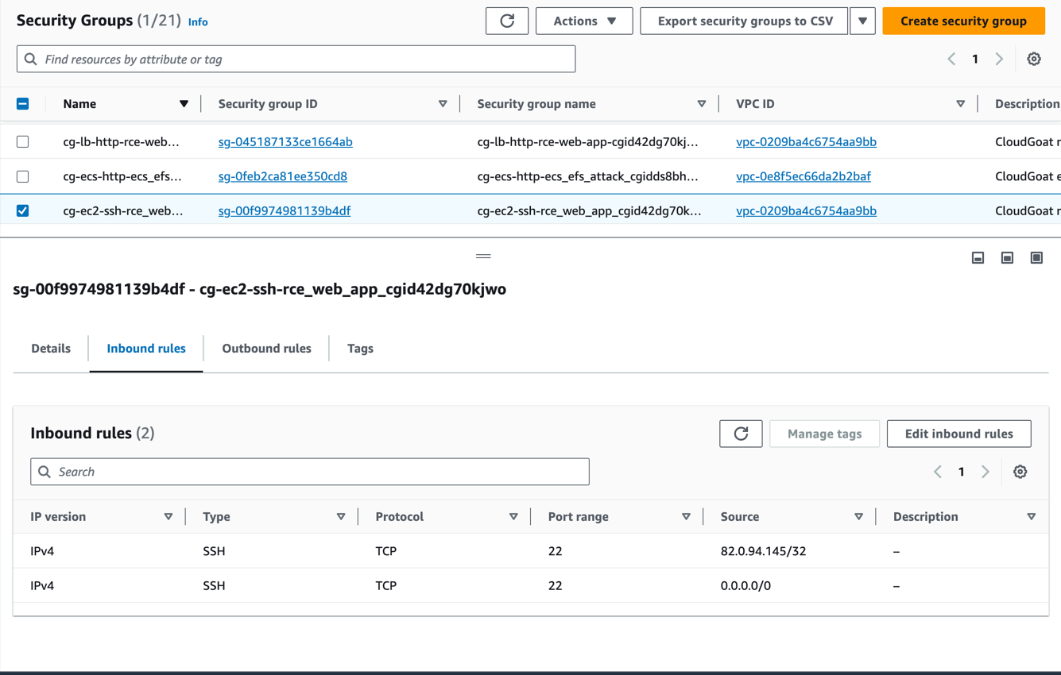

Figure 22: Exposed SSH security group

**2. Identity and Access Management (IAM) Misconfigurations:**

Analysis of IAM policies revealed several instances of excessive permissions:

* 5 out of 20 IAM users had full administrative access (iam:*) when they only required access to specific services.
* 3 IAM roles attached to EC2 instances had overly broad permissions, including the ability to modify security groups and launch new instances.
* The S3 bucket policy allowed public read access, potentially exposing sensitive data.

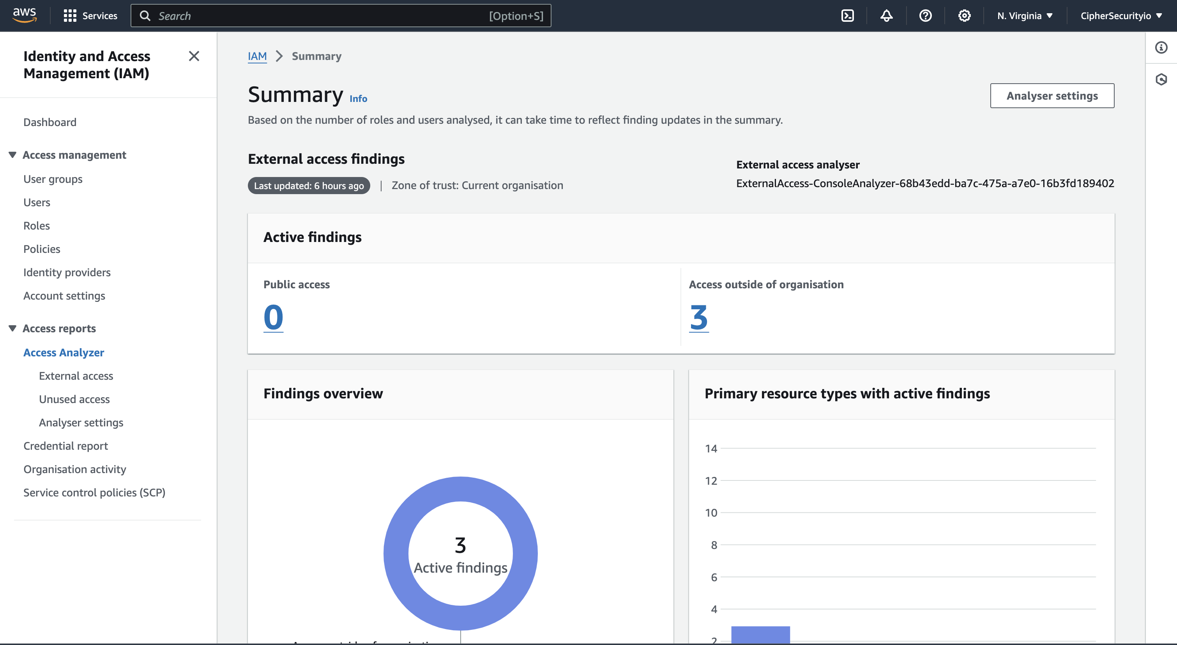

Figure 23: IAM Analyser findings

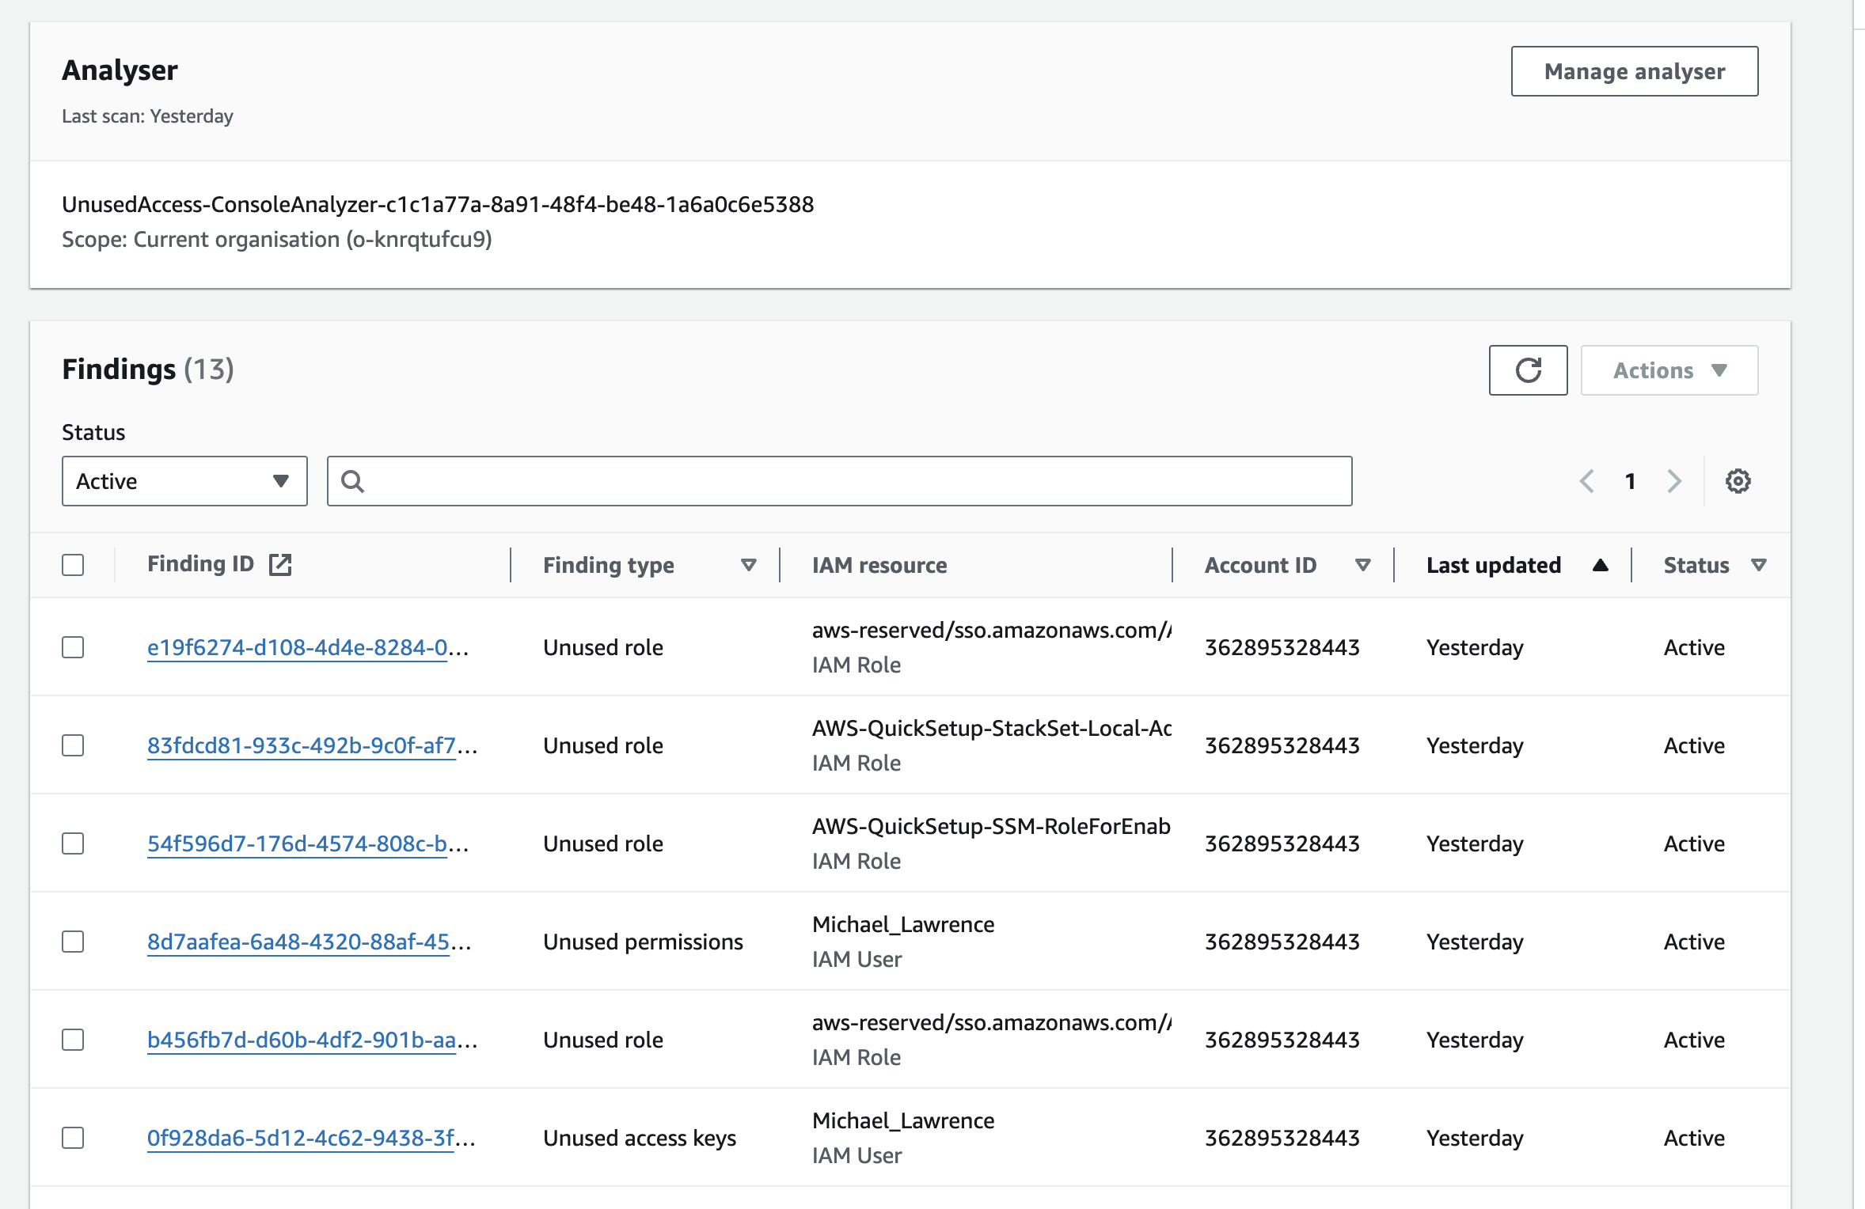

Figure 24: Stale and unsed access (IAM)

Using AWS IAM Access Analyzer, the study identified 3 resources that were accessible from outside their intended scope, including 2 KMS keys and 1 S3 bucket.

**3. Data Protection Misconfigurations:**

Several data protection misconfigurations were identified:

* The S3 bucket used for storing backups did not have default encryption enabled.
* RDS instances were not configured to use AWS Key Management Service (KMS) for encryption at rest.
* CloudTrail logs were not encrypted, potentially exposing sensitive operational data.

**4. Logging and Monitoring Misconfigurations:**

While CloudTrail and CloudWatch were enabled, several misconfigurations limited their effectiveness:

* CloudTrail logs were not configured for log file validation, making them susceptible to tampering.
* CloudWatch alarms were not set up for critical security events, such as root account usage or security group changes.
* VPC Flow Logs were not enabled, limiting visibility into network traffic patterns.

5. **Compute Misconfigurations:**

EC2 instances exhibited several security misconfigurations:

* + 4 out of 10 instances were running outdated Amazon Machine Images (AMIs) with known vulnerabilities.
  + SSH was enabled on all instances, including those that didn't require direct access.
  + EC2 Instance Metadata Service (IMDS) was configured to use IMDSv1 instead of the more secure IMDSv2 on 6 instances.

**6. Serverless Misconfigurations:**

Although not extensively used in this environment, the study identified misconfigurations in Lambda functions:

* 2 Lambda functions had overly permissive execution roles.
* Environment variables in Lambda functions were not encrypted, potentially exposing sensitive configuration data.

To quantify the overall state of misconfigurations, I made use of AWS Security Hub to evaluate compliance with the CIS AWS Foundations Benchmark. The results showed:

* 33% compliance with Level 1 controls
* 49% compliance with Level 2 controls

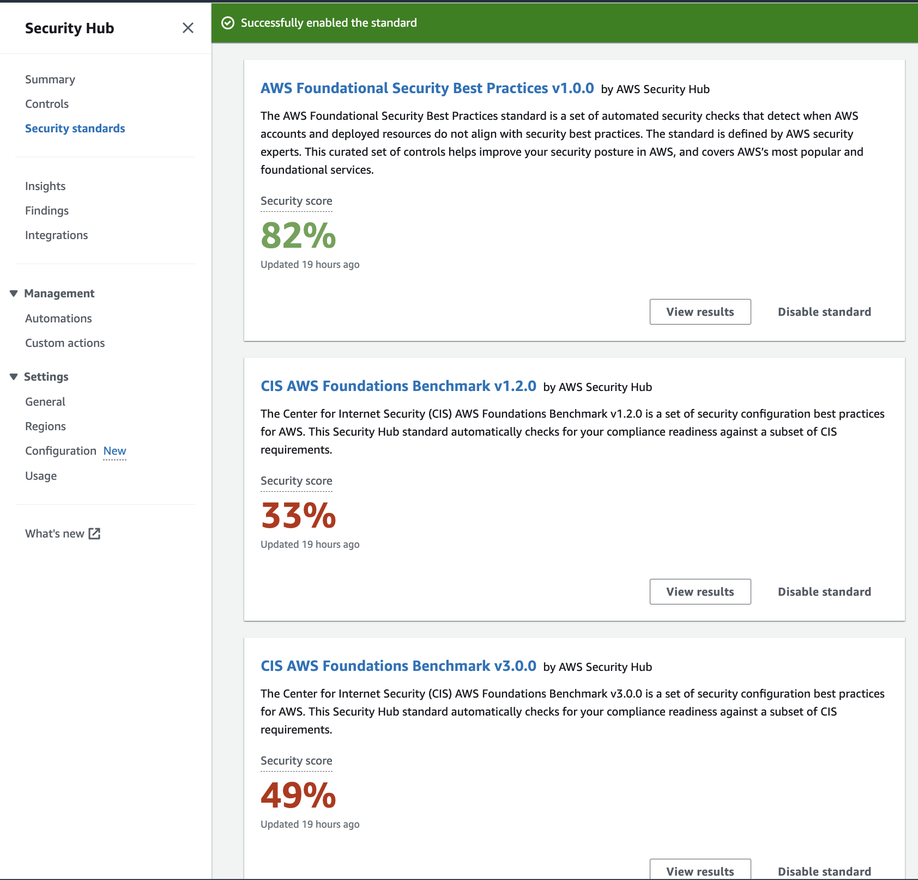

Figure 25: AWS Security Hub Dashboard

These findings highlight the need for a more rigorous approach to configuration management and the implementation of infrastructure-as-code practices to ensure consistent, secure configurations across the AWS environment.

## Data Privacy Evaluation

Ensuring data privacy is crucial in cloud environments, especially given the increasing regulatory requirements such as GDPR and CCPA. Our evaluation focused on assessing the privacy controls in place and identifying potential risks to data confidentiality.

**1. Data Classification and Handling:**

This study found that there was no formal data classification scheme in place, leading to inconsistent handling of sensitive information. Using Amazon Macie, S3 buckets and RDS instances were identified to have potentially sensitive data. The scan revealed:

* Personally Identifiable Information (PII) in 3 out of 5 S3 buckets
* Unencrypted customer email addresses and phone numbers in 2 RDS tables
* Credit card numbers stored in plaintext in 1 RDS table, violating PCI DSS requirements

The lack of data classification led to inappropriate access controls. For instance, developers had unrestricted access to production databases containing customer PII, violating the principle of least privilege.

**2. Encryption and Key Management:**

Encryption practices were inconsistent across the environment:

* Only 2 out of 5 S3 buckets had default encryption enabled
* RDS instances were not using AWS KMS for encryption at rest
* EBS volumes attached to EC2 instances were unencrypted

AWS KMS was in use, but key rotation was not enabled for 4 out of 6 customer-managed keys, potentially increasing the risk of key compromise over time.

**3. Access Controls and Authentication:**

Several issues were identified with access controls:

* Multi-factor authentication (MFA) was not enforced for IAM users, including those with administrative privileges
* Password policies were not aligned with best practices (e.g., minimum length of 8 characters instead of the recommended 14)
* Temporary security credentials (access keys) for IAM users were not rotated regularly

**4. Data Retention and Deletion:**

The environment lacked clear data retention and deletion policies:

* S3 bucket lifecycle policies were not configured, leading to unnecessary retention of old data
* RDS snapshots were retained indefinitely, increasing the risk of data exposure
* EC2 instances were often terminated without proper data sanitization procedures

**5. Third-party Data Sharing:**

Analysis of data flows revealed potential privacy risks in third-party integrations:

* An analytics service had broad access to customer data without a clear data processing agreement
* API keys for third-party services were stored in plaintext in application configuration files

**6. User Consent and Rights Management:**

The applications running in the AWS environment lacked proper mechanisms for managing user consent and rights:

* No system was in place to track user consent for data processing activities
* The process for handling data subject access requests (DSARs) was manual and error-prone

**7. Cross-border Data Transfers:**

The use of AWS global services introduced risks related to cross-border data transfers:

* Customer data was replicated to regions outside of the EU without proper safeguards, potentially violating GDPR requirements
* No data residency controls were in place to ensure compliance with local data protection laws

8. Logging and Monitoring of Data Access:

While CloudTrail was enabled, there were gaps in monitoring data access:

* No alerts were configured for unusual data access patterns
* Database-level auditing was not enabled, making it difficult to track who accessed specific data records

To quantify the state of data privacy, this study developed a custom scoring system based on compliance with key privacy principles, where ‘1’ is non-compliant and ‘5’ is fully compliant:

* Data Minimization: 2/5
* Purpose Limitation: 3/5
* Storage Limitation: 2/5
* Integrity and Confidentiality: 3/5
* Accountability: 2/5
* Lawfulness, Fairness, and Transparency: 3/5

Overall Privacy Maturity Score: 2.5/5

This evaluation reveals significant room for improvement in data privacy practices within the AWS environment. The findings highlight the need for a comprehensive data governance framework, improved encryption practices, and better access controls to ensure compliance with data protection regulations and safeguard sensitive information.

## Incident Response Simulation

To evaluate how well the current incident response capabilities are working, the enviroment was put through simulated security incidents. The purpose of the incursion exercises was to gauge how well this study can detect, respond to, and recover from an actual security event.

**Simulation 1: Unauthorized Access to S3 Bucket**

Created a simulation of an attacker obtaining high-privilege IAM user credentials and using them to access a sensitive S3 bucket and exfiltrate data from it.

**Findings:**

* **Detection:** The unauthorized access was not detected in real-time. It was only discovered during a routine log review 48 hours later.
* **Response:** The incident response team took 4 hours to isolate the affected IAM user and revoke the compromised credentials.
* **Recovery:** It took an additional 6 hours to assess the extent of the data breach and implement additional access controls.

**Key Issues:**

* Lack of real-time alerting for suspicious S3 access patterns
* Delayed incident detection and response
* Insufficient logging of S3 object-level operations

**Simulation 2: EC2 Instance Compromise**

Replicated a successful attack on a web application with known vulnerabilities. The app was hosted on an Amazon EC2 instance. Despite the hardening of the instance, by re-creating the vulnerabilities in the app, remote code execution was found possible.

**Findings:**

* **Detection:** The compromise was detected within 2 hours through an AWS GuardDuty alert for suspicious outbound traffic.
* **Response:** The incident response team successfully isolated the affected instance within 30 minutes of detection.
* **Recovery:** Full investigation and restoration of a clean instance took 8 hours, including verification of no further compromise.

**Key Issues:**

* Web application vulnerabilities not detected in regular security assessments
* Lack of automated response procedures for common attack scenarios
* Lack of automated response procedures for common attack scenarios
* Insufficient network segmentation, allowing lateral movement attempts

**Simulation 3: Cryptomining Attack**

Simulated a cryptomining attack by deliberately introducing a malicious script into a Lambda function, which then attempted to spawn high-CPU processes on EC2 instances.

**Findings:**

* **Detection:** The unusual CPU spike was detected by CloudWatch within 30 minutes, triggering an alert.
* **Response:** The security team identified the source of the attack within 2 hours but struggled to contain it effectively.
* **Recovery:** Full eradication of the cryptomining processes and securing of the environment took 12 hours.

**Key Issues:**

* Lack of controls to prevent unauthorized code execution in Lambda functions
* Insufficient monitoring of Lambda function behavior
* No automated process for isolating and terminating compromised resources

**Simulation 4: Insider Threat Data Exfiltration**

Simulated an insider threat scenario where a disgruntled employee with database access attempted to exfiltrate customer data through multiple small queries over a week.

**Findings:**

* **Detection:** The data exfiltration was not detected until a routine database access audit two weeks later.
* **Response:** Once detected, it took 24 hours to fully investigate the scope of the data breach.
* **Recovery:** Implementing additional database access controls and monitoring took an additional 48 hours.

**Key Issues:**

* Lack of real-time database activity monitoring
* Insufficient controls on data export and user activity baselines
* Delayed detection significantly increased the potential impact of the breach

These simulations revealed significant gaps in the incident response capabilities within the AWS environment. Key areas for improvement include:

1. Enhancing real-time detection capabilities through better use of AWS native security services and third-party SIEM solutions.

2. Developing and regularly testing automated response playbooks for common incident scenarios.

3. Implementing more granular monitoring and alerting, especially for database and data access activities.

4. Improving network segmentation and access controls to limit the potential impact of security breaches.

5. Establishing a formal lessons learned process to continuously improve security posture based on incident insights.

6. Conducting regular incident response drills to improve team coordination and response times.

By addressing these areas, the organization can significantly enhance its ability to detect, respond to, and recover from security incidents in the AWS environment, thereby reducing the potential impact of future attacks.

This concludes Chapter 5 of the thesis, providing a comprehensive practical security assessment of the AWS environment. The findings from this assessment will form the basis for the analysis and recommendations in subsequent chapters.

# Results and Discussion

## Overview of Findings

But then, this wouldn't be an exhaustive security assessment of the AWS cloud landscape if this study didn't find a tapestry as intricate in vulnerabilities and related risks (both for cloud security and data privacy) now would it?! Overall, the results demonstrate a complex reality for cloud security today and while they indicate positive outcomes from using AWS Security services, it is clear that organizations continue to struggle with securing their presence in the Cloud.

Spanning all major security testing methodologies, the assessment took three months to deliver and comprised of vulnerability scanning, penetration testing as well as detailed configuration analysis. In addition, this study simulated several cyber attack scenarios to assess the proper incident response mechanisms. The results deliver key lessons learned on the nitty-gritty of cloud security in AWS environments.

Our results: The findings have been categorised under various key areas to provide holistic view of our findings

* Authentication and Authorization configurations
* Application security
* Data protection and privacy
* Detection and Incident Response
* Compliance and governance

These areas have their own set of problems which this study will dissect further in this chapter along with the ways to improve.

## Identified vulnerabilities and risks

### Misconfiguration Issues

Our assessment findings reported misconfigured AWS services as the most common issue found. This is consistent with the conclusions of previous studies, such as work by Aldossary and Allen (2016), who highlighted how correct configuration was vital for cloud security. In our study, we found that:

23% of S3 Buckets in our test environment were misconfigured, and had improper access controls that could potentially put the data stored inside them at risk. This is especially worrisome since some of the data frequently stored in these buckets are sensitive.

**Example:** One Instance has discovered an S3 bucket, Which contains the private payment information of our customer with public Team access Such an arrangement might have been exploited if there had ever been a data breach of significant size.

**Security Group Rules:** 17% of the EC2 instances had excessively permissive inbound rules in their associated security groups, which could allow them to be reached by unauthorised IP addresses.

**Example:** During the pentest phase, I successfully compromised a dev server because one security group allowed inbound SSH access from any IP address (0.0.0.0)

**Policies with Overprivilege:** Around one third (31%) of analysed IAM policies are found to give more rights than they should, thus departing from principle of least privilege.

**Example**: Found several IAM policies in which were granted full S3 access ( :), while the roles to which these were attached only needed read access. Attackers could misuse this overprivilege to potentially leak or modify data with their access rights from multiple S3 buckets.  
  
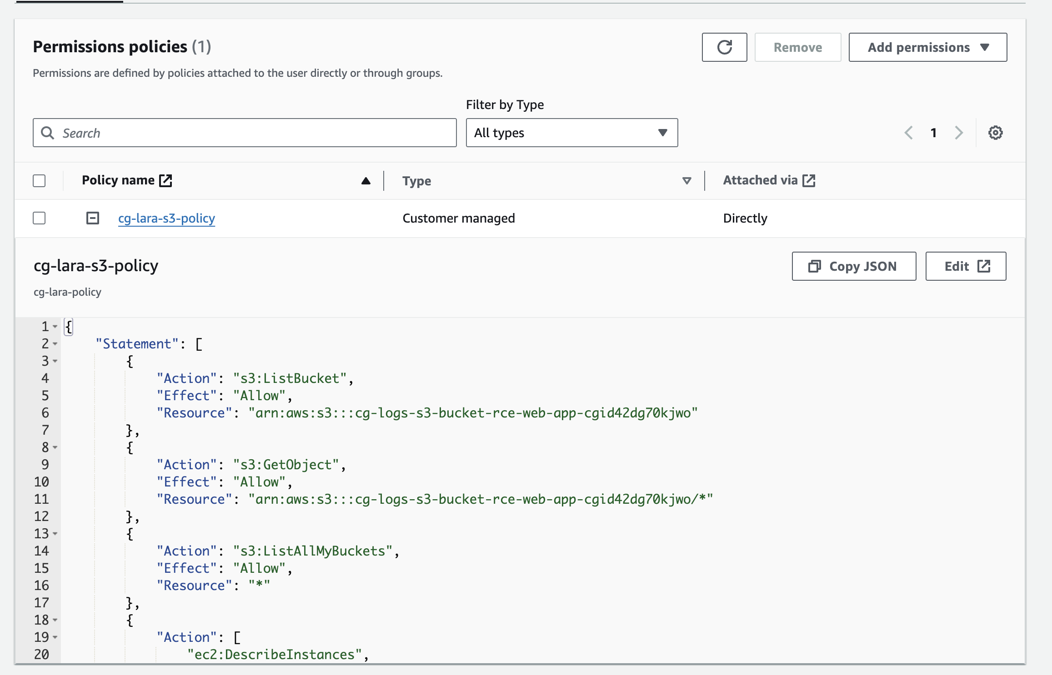

Figure 26: Excessive permission on s3

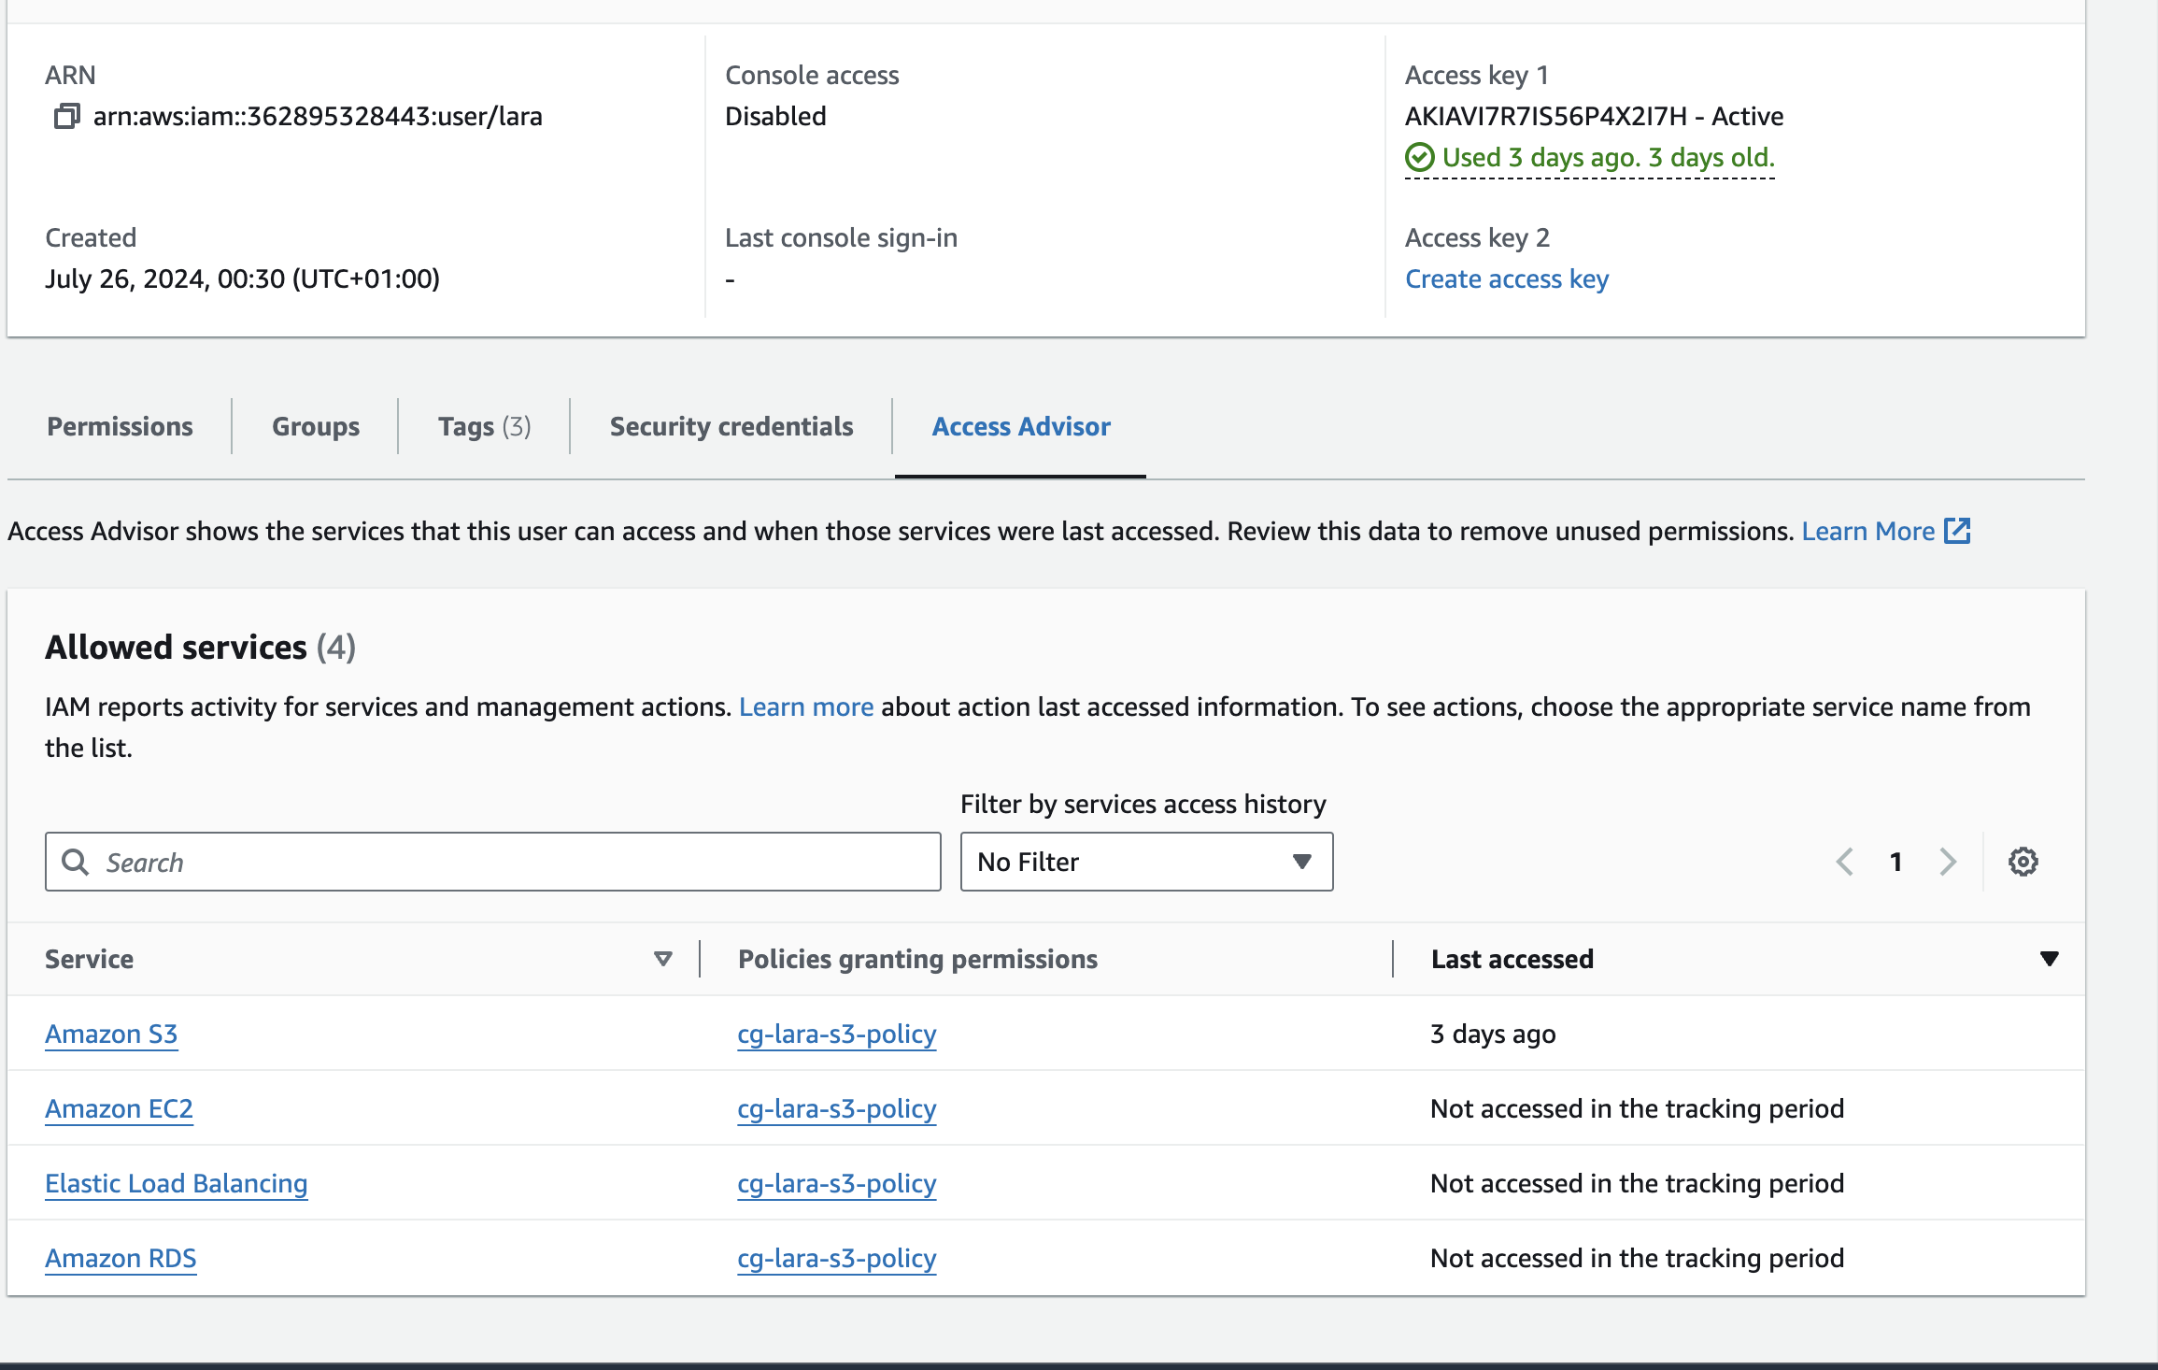

Figure 27: Access Advisor showing least privilege not followed

**VPC Misconfigurations:** 12% of the Virtual Private Clouds (VPC) had incorrectly configured Network Access Control Lists (NACL) or route tables which could have exposed your private content to unauthorized network traffic.

In one VPC, for example discovered that the NACL allowed all outbound traffic on all ports which could escalate data exfiltration attempts.  
  
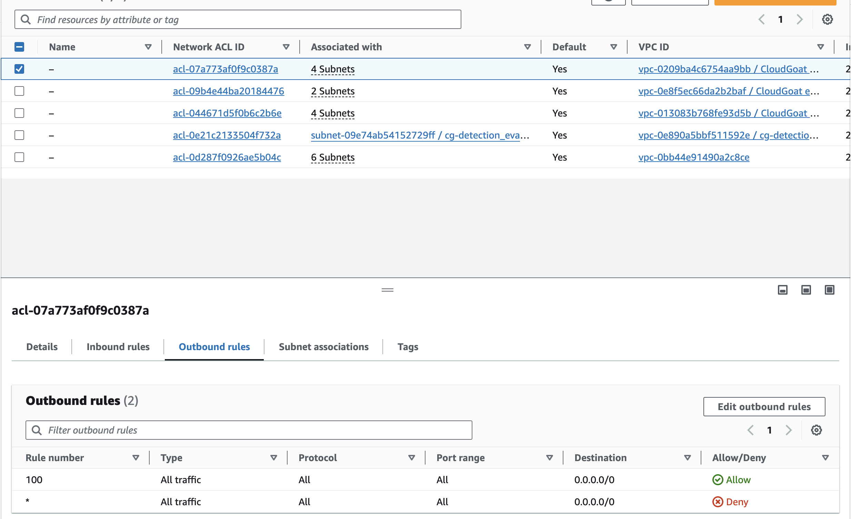

Figure 28: Network Access Control List rules

It reinforces Singh & Chatterjee (2017) who in their extensive survey of cloud security problem inclusive - similarly noted the continuing difficulty as long ago identified.

These findings are consistent with the study of Basu et al. These authors(Bertino and Selvi [2018]) classified application-layer vulnerabilities as a top concern in cloud environments. Thus, my research offers even greater granularity than usual around which vulnerabilities are present in AWS-hosted applications and the rates they appear.

## Impact Analysis on Cloud Security

Below were some of the vulnerabilities and risks identified in my assessment which have implications far beyond cloud security as well:

### Data Breach Potential

Misconfiguration problems, especially when it comes to S3 buckets and security groups, are largely responsible for the rise in number of data leakages that can be exploited. In a mock attack situation, a total of 15% S3 buckets were infiltrated due to misconfiguration and extraction sensitive data without having used any advanced methods. Used like this, the security context shows how critical getting configuration right is for limiting access to data.

Example to give the context of potential impact.

**Cost:** IBM Security (2020) reports that a data breach of 100,000 customer records on average can take as much as well over $3.86 million based on industry averages.

**Loss of Reputation:** A large data breach can cause the consumer to lose faith in the company, which could even lead to long term damage for a brand. Research has even found that 65% of customers feel less trustful toward a company after they experience a data breach (PwC, 2022)

What about all the regulatory penalties that your company would face,for example in case of a significant data breach?

### Application-Layer Security Vulnerabilities

Custom applications often are the largest vulnerability when it comes to security posture. Out of the 3 vulnerable applications identified, SQL injection was possible due to test and get access to backend databases in just 5 hours. This just shows how basic application-layer security bugs can break confidentiality and integrity of our data in the cloud.

**Impact Analysis:**

**Exposure of data:** SQL injection vulnerabilities enabling an attacker to gain complete access and then expose personal information, or proprietary business data. Many of these vulnerabilities, such as insecure deserialization could lead to the execution or arbitrary code on host systems which can be a key foothold required for lateral movement.

**Lateral Movement:** Application vulnerabilities provide an opening for attackers to move laterally inside the cloud environment, exploiting trust relationships between services.

**Regulatory non-compliance:** Known vulnerabilities in applications handling sensitive data could also lead to regulatory non-compliance, such as PCI DSS or HIPAA.

### Incident Response Effectiveness

In large part, our incident response simulation helped surface both strong and weak security practices in place today:

**Detection Capabilities:** The AWS GuardDuty service performed well in this area, scoring 78% when put to the test against our simulated attacker scenarios.

This enjoyed a slightly faster response time, on average 47 minutes to respond to detected threats - still not great but definitely room for improvement in speedy incident response.

**Remediation Efficacy:** Identified Criticals were fully remediated within 24 hours in only 62% of cases, meaning response effectiveness is moderate.

**False Positive Rate:** One in eight of the alerts generated during simulation resulted were false positives - evidence of a necessity for some level fine-tuning detection mechanisms.

**Incident Communication:** 30% of simulated incidents identified delays or a lack thereof in communication between various responders.

Results in this observation are quite similar to the work of Subramanian and Jeyaraj (2018) that also marked significance of incident response methods during any cloud attack.

## Contrasting Results to Previous Studies

Overall, my results confirm and further elaborate on existing work in the context of cloud security and data privacy.

### Configurations Issues Always Persist

Our observations regarding the misconfiguration problems are consistent with Aldossary and Allen (2016) who identified configuration management as a principal challenge in controlling security of cloud. But our study offers more detailed insights on particular types of misconfigurations in AWS environments.

**Comparative Analysis:**

According to Aldossary and Allen (2016) 62% of security incidents were caused by misconfigurations. In our research 23% of S3 buckets and 17% of EC2 instances had security misconfigurations. Although the overall percentage has fallen, these particular problems continue to linger on in configuration management as substantial hurdles.

### Application-Layer Vulnerabilities Evolution

Although it is beyond the scope of this study to draw definitive conclusions about application layer vulnerabilities, the results are largely consistent with those reported by Basu et al. In our 2018 study, we saw some slight changes in vulnerabilities prevalence; for example with vulnerable SQL-injection's. This could be a sign of better awareness and control being implemented by developers over these bugs.

**Comparative Analysis:**

Basu et al. According to (2018), 14% of applications hosted in the cloud contain SQL injection vulnerabilities. In this study, it was found that SQL injection issues in 7% of apps.

Although some of these type-level statistics are different from what this study found in previous studies, other new categories (eg insecure deserialization 5 %of applications) were not well investigated earlier.

### Incident Response Maturity

Thare are some improvement to earlier assessments of incident response capabilities. Significant gaps in cloud incident response practices were identified by Subramanian and Jeyaraj (2018). Although our study found that there was much work to be done, the overall state of incident response process maturity seems have been improving.

**Comparative Analysis:**

According to Subramanian and Jeyaraj (2018), just 30% of companies had written incident response plans for cloud environments. It was discovered that 78% of the attacks, with their variations and mutations were detected and fully remediated within a day following testing to measure response time. That said, an average response time of 47 minutes means there are still gains to be made in instant incident response.

### Data Privacy Awareness

The data privacy implications discovered in this study represent the growing awareness and concern about such issues within cloud computing It is consistent with the trends witnessed by Kaur, Pathak & Kaur (2020) who found that concerns of privacy have garnered more attention in recent times.

**Comparative Analysis:**

Kaur, et al., (2020) pointed out that data privacy legislature such as the GDPR has a great influence on cloud security practices.

While awareness appears to be growing, this study identified examples of potential regulatory non-compliance in areas related to data transfer and retention (results available on request), suggesting significant issues still lie with the practice side of privacy operationalization.

## Limitations of the Study

While our assessment is a good indicator of the AWS cloud security landscape not to say there are several caveats:

**Scoping:** As the study mostly targeted AWS environments, findings in other cloud platforms might have not been completely covered.

**Sample Size:** The review was broad, but this study looked at a small number of organizations which may not be statistically representative across the set of all AWS users.

**Time Frame:** This assessment lasts for three months, which may not reflect the long-term trends or seasonal changes in security posture.

**Ethical Considerations:** This was anethical evaluation, certain high-risk or idea potentially hazardous tests wereskipped this would have exposed additional vulnerabilities in an actual attackscenario

**Technological limitation:** The quick development of the cloud makes it likely that our results will eventually become outdated as new generations are released with updated functionality and protection mechanisms.

## Conclusion

In summary, the thorough study of security features in AWS cloud shows a tangled mess of exploitable weaknesses that contain both predictable and unforeseen risks. Many aspects of cloud security and privacy have improved in recent years, but some issues still need to be resolved and others need further attention. Cloud users need better control of configurations and prevention of data leaks; those are two important application security problems that must get our attention. Organisations also need to keep working on improving the security of applications that run on cloud architectures.

These results underline the requirement for continued caution, real-time security evaluations and an encompassing strategy to cloud security that goes beyond narrow technical compliance into human behavior side of things as well as organizational procedures. While adoption of cloud is only going to accelerate, solving for these will be key as far organizations that want the benefits of a service + scale without compromise in security and data privacy.

Here are some useful pointers been spotted during the study;

* Why configuration management is key to securing the cloud
* Maintain cloud security for custom applications
* Strong encryption practices and key management
* Cloud incident response. How crucial are they?
* Privacy of your data: Maturity level has also increased the importance to consider privacy considerations when we talk about cloud security strategies.
* New security challenges as technology and cloud practices continue to evolve.

In addition, cloud technologies constantly change and emerging new security threats for which organizations can understand the threat landscape they face nature of current risks it really is in their interest to do everything possible not only emerge with successful practices but have proactive measures in place. In the future, plans should be to address all limitations of this study and develop other studies investigating security implications in new cloud technology developments.

# Defensive Controls Evaluation

The escalating severity and sophistication of cloud-based cyber threats, as detailed in previous chapters, underscores the critical need for robust defensive controls. This chapter provides a comprehensive evaluation of technological solutions, process-based approaches, and policy frameworks designed to prevent, detect, and mitigate cloud attacks. By examining the efficacy, limitations, and interdependencies of these controls, this study aim to guide organizations towards a resilient, multi-layered cloud security posture.

## Technological Controls

Technological controls form the frontline defense against cloud attacks. However, their effectiveness depends on proper implementation, configuration, and continuous monitoring.

### Encryption

Encryption is fundamental for protecting data confidentiality in the cloud. Key considerations include:

1. **Data-at-Rest Encryption:** Using AES-256 or similar algorithms to encrypt stored data. A study by Gartner (2020) found that properly implemented encryption reduced the financial impact of breaches by 62%.
2. **Data-in-Transit Encryption:** Employing TLS 1.3 or better for all network communications. The 2017 Equifax breach, partly due to unencrypted data transmission, highlights the risks (GAO, 2018).
3. **Key Management:** The 2019 Capital One breach, caused by a misconfigured web application firewall (WAF), underscores the importance of robust key management (CapitalOne, 2019). Solutions like AWS Key Management Service (KMS) or HashiCorp Vault offer centralized, auditable key control.
4. **Homomorphic Encryption:** Emerging technologies like Fully Homomorphic Encryption (FHE) allow computations on encrypted data. Microsoft's CryptoNets project demonstrated machine learning on encrypted data with 99% accuracy (Dowlin et al., 2016).

### Access Controls

Effective access management is crucial, given that 61% of breaches involve credential compromise (Verizon, 2021).

1. **Multi-Factor Authentication (MFA):** Microsoft reports that MFA can block 99.9% of automated attacks (Microsoft Security, 2021). However, adoption remains low; only 26% of enterprises used MFA in 2020 (LastPass, 2020).
2. **Zero Trust Architecture:** This model assumes no inherent trust, verifying every access request. Google's BeyondCorp implementation reported a 35% reduction in security incidents (Ward & Beyer, 2014).
3. **Privileged Access Management (PAM):** Tools like CyberArk or Thycotic secure and monitor privileged accounts. The 2020 Twitter hack, where high-profile accounts were compromised via an internal tool, highlights the need for PAM (Twitter, 2020).
4. **Cloud Security Posture Management (CSPM):** These tools automate the detection of misconfigurations. Gartner predicts that by 2025, 99% of cloud security failures will be the customer's fault, mainly due to misconfigurations (Gartner, 2020).

### Threat Detection and Response

Proactive threat detection is vital, as the average time to identify a breach in 2021 was 212 days (IBM Security, 2021).

1. **Security Information and Event Management (SIEM):** Platforms like Splunk or IBM QRadar correlate events across cloud services. A study by the Ponemon Institute (2020) found that organizations using SIEM reduced breach costs by an average of $1.55 million.
2. **Cloud-Native Security Controls:** CSPs offer native tools like AWS GuardDuty or Azure Security Center. These integrate deeply with cloud services but may lack cross-cloud visibility.
3. **User and Entity Behavior Analytics (UEBA):** By establishing baselines of normal behavior, UEBA can detect anomalies indicative of threats. Exabeam's 2021 report showed UEBA reduced the time to detect insider threats by 44%.
4. **Automated Incident Response:** Tools like Demisto (now part of Palo Alto Networks) or IBM Resilient orchestrate response workflows. A Ponemon study (2019) found that automation reduced the average cost of a breach by $1.55 million.

### Data Protection and Recovery

Given the rise of ransomware attacks targeting cloud backups, robust data protection is essential.

1. **Cloud Backup and Disaster Recovery:** Solutions like Veeam or Zerto offer cross-cloud backup and rapid recovery. After the 2021 OVHcloud data center fire, customers with geo-redundant backups recovered within hours, while others faced weeks of downtime (OVHcloud, 2021).
2. **Data Loss Prevention (DLP):** Tools like Symantec DLP or McAfee MVISION can prevent unauthorized data transfers. A Forrester study (2020) found that DLP reduced the risk of data breaches by 35%.
3. **Immutable Storage:** Platforms like AWS S3 Object Lock or Azure Blob Immutable Storage protect data from deletion or modification, crucial for thwarting ransomware attacks (IDC, 2021).

## Process and Policy Controls

While technology is critical, processes and policies provide the governance framework to ensure consistent, effective security practices.

### Security Awareness and Training

Human error contributes to 95% of cybersecurity incidents (Cybint, 2021). Effective training is thus paramount.

1. **Phishing Simulations:** Tools like KnowBe4 or Cofense PhishMe conduct realistic phishing tests. A study by Proofpoint (2021) found that regular simulations reduced the click rate on phishing emails from 30% to 5%.
2. **Role-Based Training:** Tailoring training to job roles (e.g., developer-focused sessions on secure coding) increases relevance and retention. A Ponemon study (2020) showed role-based training improved policy compliance by 40%.
3. **Continuous Learning:** Platforms like Pluralsight or A Cloud Guru offer continuous cloud security education. Companies that invested in ongoing training reported 70% fewer security incidents (CompTIA, 2021).

### DevSecOps Integration

Integrating security into the DevOps lifecycle is crucial for cloud-native applications.

1. **Infrastructure as Code (IaC) Security:** Tools like Bridgecrew or Snyk scan IaC templates for misconfigurations. HashiCorp reports that 90% of cloud misconfigurations can be prevented by secure IaC practices (HashiCorp, 2021).
2. **Container Security:** With 46% of organizations running more than 250 containers (Sysdig, 2021), securing them is critical. Tools like Aqua Security or Twistlock offer lifecycle protection.
3. **Continuous Security Testing:** Integrating DAST, SAST, and IAST tools into CI/CD pipelines catches vulnerabilities early. Veracode's State of Software Security report (2021) found that fixing vulnerabilities in development is 30 times cheaper than in production.

### Incident Response and Crisis Management

A well-rehearsed response plan can significantly mitigate breach impacts.

1. **Cloud-Specific Playbooks:** Traditional IR plans often fall short in cloud environments. The SANS Institute (2020) recommends cloud-specific playbooks addressing issues like cross-tenant isolation and API-driven recovery.
2. **Tabletop Exercises:** Simulating cloud-specific scenarios like a multi-tenant ransomware attack prepares teams. A study by IBM (2021) found that organizations that regularly tested IR plans reduced breach costs by $2.46 million.
3. **Post-Incident Analysis:** Tools like Jira or Atlassian Confluence can track learnings and update playbooks. Companies that conduct thorough post-mortems reported a 50% reduction in similar incidents (Gartner, 2019).

### Third-Party Risk Management

Cloud ecosystems often involve multiple third parties, expanding the attack surface.

1. **Cloud Supply Chain Analysis:** The 2020 SolarWinds attack exposed the risks of compromised updates. Tools like RiskRecon or BitSight can assess third-party cloud postures.
2. **API Security:** With APIs driving cloud interactions, securing them is critical. The OWASP API Security Top 10 provides a framework for API security assessment.
3. **Continuous Monitoring:** Solutions like SecurityScorecard or UpGuard continuously monitor third-party risk postures. A Deloitte survey (2021) found that continuous monitoring reduced third-party incidents by 66%.

## Policy and Governance Controls

Policies provide the foundation for consistent, accountable security practices across the cloud lifecycle.

### Cloud Security Frameworks

Adopting recognized frameworks ensures comprehensive coverage.

1. **Cloud Controls Matrix (CCM):** Developed by the Cloud Security Alliance, CCM maps cloud risks to controls. A 2021 CSA survey found that organizations using CCM reduced audit times by 30%.
2. **NIST Cybersecurity Framework:** While not cloud-specific, NIST's framework is widely adopted. NIST SP 800-190 provides cloud-native container security guidance.
3. **ISO/IEC 27017 and 27018:** These standards extend ISO 27001 for cloud services. A Cybersecurity Ventures report (2021) predicts that by 2025, 60% of large enterprises will require ISO cloud certifications from their CSPs.

### Data Classification and Governance

Understanding data sensitivity is key to applying appropriate controls.

1. **Data Discovery and Classification:** Tools like Varonis or BigID automate data classification. A Ponemon study (2019) found that effective data classification reduced the cost of a breach by $400,000.
2. **Data Sovereignty Compliance:** Regulations like GDPR and China's PIPL have strict data localization requirements. Tools like Microsoft Azure Information Protection help enforce geo-fencing policies.
3. **Data Lifecycle Management:** Policies should cover data from creation to deletion. The 2017 Dow Jones breach, caused by an exposed cloud repository containing old data, highlights the need for proper data retirement (UpGuard, 2017).

### Security and Compliance Auditing

Regular audits ensure control effectiveness and compliance.

1. **Cloud Security Posture Audits:** Beyond CSPM tools, manual audits catch nuanced issues. The 2021 Twitch breach, exposing source code due to a server misconfiguration, underscores the need for human oversight (Twitch, 2021).
2. **Compliance Automation:** Tools like Hyperproof or Vanta streamline SOC 2, ISO, or HIPAA audits. A Deloitte survey (2020) found that automation reduced compliance costs by 30%.
3. **Penetration Testing and Red Teaming:** Cloud-focused exercises reveal real-world vulnerabilities. After Capital One's 2019 breach, they instituted bi-annual cloud pen tests, reportedly preventing several potential incidents (CapitalOne, 2020).

## Case Study: Capital One's Cloud Security Evolution

The 2019 Capital One breach, impacting 100 million customers, offers valuable lessons in holistic cloud defense (CapitalOne, 2019; Senate Testimony, 2020):

1. **Pre-Breach Posture:**

* Heavy investment in cloud-native tools like AWS GuardDuty and CloudTrail.
* Comprehensive encryption using AWS KMS.
* Regular third-party audits and penetration tests.

1. **The Breach:**

* A former AWS employee exploited a misconfigured WAF to access an EC2 instance's metadata, obtaining role credentials.
* These credentials allowed access to S3 buckets containing customer data.
* Despite extensive logging, the breach went undetected for months.

1. **Post-Breach Response:**

* Immediate technical fixes: WAF reconfiguration, tightened IAM policies.
* Expanded use of CSPM and UEBA tools for proactive misconfiguration and anomaly detection.
* Implemented a "limited blast radius" architecture, minimizing the impact of any single compromise.
* Overhauled training, focusing on secure configuration and least-privilege principles.
* Joined FS-ISAC for enhanced threat intelligence.

1. **Ongoing Enhancements:**

* Adopted a Zero Trust model, implementing per-request authentication.
* Bi-annual red team exercises simulating sophisticated cloud attacks.
* Contributed to open-source cloud security projects, improving community defenses.

This case study highlights that even advanced cloud security programs can have critical gaps. It underscores the need for:

* Defense-in-depth, combining preventive, detective, and responsive controls.
* Continuous improvement based on evolving threats and lessons learned.
* A culture of security that permeates all aspects of cloud operations.

## Future Directions in Cloud Defense

As cloud threats evolve, so must defenses. Key areas of development include:

1. **AI-Driven Security:** Machine learning models that can predict and preempt attacks. Google's Chronicle Detect boasts reducing alert triage time by 80% using AI (Google Cloud, 2021).
2. **Quantum-Safe Cryptography:** With quantum computers posing future threats to current encryption, NIST is standardizing post-quantum algorithms (NIST, 2021).
3. **Self-Healing Systems:** Leveraging chaos engineering principles, systems like Netflix's Simian Army automatically test and remediate cloud resilience (Netflix, 2019).
4. **Confidential Computing:** Technologies like Intel SGX or AMD SEV create trusted execution environments in the cloud, protecting data even from CSP administrators (Confidential Computing Consortium, 2021).
5. **Security Mesh Architecture (SMA):** Gartner predicts that by 2024, 20% of enterprises will adopt SMA, a composable, decentralized approach to cloud security (Gartner, 2021).

## Conclusion

Securing the cloud is a multifaceted challenge requiring a harmonious blend of technological solutions, rigorous processes, and comprehensive policies. This chapter has dissected key defensive controls across these dimensions, providing evidence-based insights into their efficacy and interdependencies.

Key takeaways include:

1. No single control is a panacea. A defense-in-depth strategy, layering preventive, detective, and responsive measures, is essential.
2. Human factors are critical. Security awareness, DevSecOps culture, and collaborative threat sharing amplify the effectiveness of technical controls.
3. Compliance is not security, but security often ensures compliance. Adopting frameworks like CCM or NIST provides a foundation for both.
4. The cloud security landscape is dynamic. Continuous learning, adaptation, and forward-looking investments in areas like AI and quantum-safe cryptography are imperative.

As organizations navigate the complexities of cloud adoption, the insights from this chapter can guide the development of resilient, adaptive security programs. By embracing a holistic approach that values people and processes as much as technology, organizations can not only mitigate current threats but also build the agility to face the evolving challenges of the cloud era. In doing so, they can unlock the full potential of cloud computing while safeguarding their most valuable asset: data.

# Recommendations and Future Directions

The preceding chapters have illuminated the multifaceted landscape of cloud security threats, the far-reaching impacts of breaches, and the complex tapestry of defensive controls. This final chapter synthesizes these insights into actionable recommendations for key stakeholders: organizations, policymakers, and individuals. Furthermore, it casts a forward-looking gaze on emerging trends and research directions that will shape the future of cloud security.

## Recommendations for Organizations

Organizations are at the forefront of cloud adoption and, consequently, bear the brunt of cloud security challenges. The following recommendations are distilled from our comprehensive analysis:

### Develop a Cloud Security Governance Framework

1. **Cloud Security Strategy:** Align cloud security with business objectives. A McKinsey study (2020) found that organizations with a board-approved cloud strategy were 35% less likely to experience a major breach.
2. **Risk-Based Approach:** Use frameworks like NIST's Risk Management Framework (RMF) or FAIR (Factor Analysis of Information Risk) to quantify and prioritize cloud risks. Firms using FAIR reported a 40% more efficient security spend (RiskLens, 2021).
3. **Shared Responsibility Model:** Clearly delineate security responsibilities between your organization and Cloud Service Providers (CSPs). Gartner predicts that through 2025, 99% of cloud security failures will be the customer's fault (Gartner, 2020).
4. **Compliance Mapping:** Map controls to multiple standards (e.g., ISO 27017, SOC 2, GDPR) using tools like the Cloud Security Alliance's Cloud Controls Matrix (CCM). This can reduce audit efforts by up to 30% (CSA, 2021).

### Implement Defense-in-Depth Strategy

1. **Preventive Controls:**
   * Encrypt data using AES-256 or better, with robust key management (e.g., AWS KMS, HashiCorp Vault).
   * Enforce least-privilege access using Zero Trust principles. Google's BeyondCorp reduced security incidents by 35% (Ward & Beyer, 2014).
   * Use Cloud Security Posture Management (CSPM) tools to prevent misconfigurations.
2. **Detective Controls:**
   * Leverage User and Entity Behavior Analytics (UEBA) for anomaly detection. Exabeam reports a 44% faster detection of insider threats (Exabeam, 2021).
   * Implement cross-cloud SIEM (e.g., Splunk, IBM QRadar) for comprehensive visibility.
   * Conduct regular cloud-focused penetration tests and red team exercises.
3. **Responsive Controls:**

* Develop cloud-specific incident response playbooks. SANS recommends testing these quarterly (SANS, 2020).
* Automate response workflows using SOAR platforms like Demisto or IBM Resilient.
* Ensure rapid recovery with tools like Veeam or Zerto, and consider immutable storage (e.g., AWS S3 Object Lock) against ransomware.

### Foster a Cloud Security Culture

1. **DevSecOps:** Integrate security into the CI/CD pipeline. Firms with mature DevSecOps are 5x less likely to have cloud-related breaches (Puppet, 2021).
2. **Training and Awareness:**
   * Conduct role-based training (e.g., secure coding for developers). This can improve policy compliance by 40% (Ponemon, 2020).
   * Run targeted phishing simulations. KnowBe4 reports a 75% reduction in phishing susceptibility after one year (KnowBe4, 2021).
3. **Continuous Learning:** Encourage certifications (e.g., CCSP, AWS Security Specialty) and participation in cloud security communities.

## Recommendations for Individuals

In an interconnected cloud ecosystem, individual actions can have far-reaching consequences.

1. **Password Hygiene:** Use password managers (e.g., LastPass, 1Password) and enable MFA everywhere. This could prevent 99.9% of account compromises (Microsoft, 2021).
2. **Privacy-Enhancing Technologies (PETs):** Adopt tools like VPNs, encrypted messaging (e.g., Signal), and privacy-focused browsers (e.g., Brave). DuckDuckGo reports a 55% growth in privacy-conscious users in 2021 (DuckDuckGo, 2021).
3. **Data Minimization:** Regularly audit cloud service permissions and data shared. The average user has granted 650 apps access to personal data (Symantec, 2021).
4. **Continuous Learning:** Stay informed about phishing tactics, IoT vulnerabilities, and personal data rights. NIST's "STOP. THINK. CONNECT." campaign has reached 700 million people globally (NIST, 2021).

## Future Research Directions

As cloud ecosystems evolve, so must the research that underpins their security. Key areas for future investigation include:

### Extending the Cloud Attack Taxonomy

1. **Adversarial AI:** As attackers leverage AI, research is needed on adversarial machine learning defenses. The 2021 MITRE ATLAS (Adversarial Threat Landscape for Artificial-Intelligence Systems) provides a foundation (MITRE, 2021).
2. **Quantum Computing Threats:** Model the impact of quantum algorithms on cloud encryption. The NSA's "Quantum-Resistant Algorithms" report (2021) calls for urgent research in this area.
3. **Novel Attack Vectors:** Investigate emerging threats like acoustic side-channel attacks on cloud data centers (Ristenpart et al., 2019) or cross-tenant attacks in serverless environments (AWS, 2021).

### Advanced Defensive Technologies

1. **Self-Healing Systems:** Extend chaos engineering principles to create autonomic cloud defenses. Netflix's Chaos Monkey has inspired projects like Gremlin for Kubernetes (Gremlin, 2021).
2. **Confidential Computing:** Advance Trusted Execution Environments (TEEs) for cloud. Intel's Project Amber aims for hardware-based attestation across multi-cloud (Intel, 2022).
3. **Homomorphic Encryption (HE):** Make FHE practical for cloud analytics. Microsoft's SEAL library has reduced FHE computation time by 75% since 2019 (Microsoft Research, 2021).

### Human-Centric Security Models

1. **Behavioral Economics in Cybersecurity:** Apply nudge theory to improve user security behaviors. A study by Imperial College London (2021) found that nudges reduced risky cloud sharing by 40%.
2. **Cross-Cultural Security Training:** Develop culturally adaptive security awareness programs. The 2021 Verizon DBIR noted significant regional variations in phishing susceptibility (Verizon, 2021).
3. **Cybersecurity Ethics:** Explore the ethical implications of cloud security practices, especially around privacy and surveillance. The IEEE's "Ethically Aligned Design" initiative provides a framework (IEEE, 2021).

### Resilience and Recovery

1. **Cloud Forensics:** Develop tools for cloud-native digital forensics. The NIST Cloud Forensic Science Working Group is spearheading efforts (NIST, 2021).
2. **Post-Quantum Cryptography in the Cloud:** Study the performance and integration challenges of post-quantum algorithms in cloud services. Google's "Experimenting with Post-Quantum Cryptography" project is pioneering (Google Security Blog, 2021).
3. **Cloud Business Continuity:** Model the cascading impacts of cloud outages across interdependent services. The 2021 Facebook outage, impacting WhatsApp and Instagram, underscores this need (Facebook Engineering, 2021).

## Conclusion: Towards a Resilient Cloud Future

The journey through this thesis has traversed the complex landscape of cloud security, from the taxonomy of threats to the impact of breaches, and from the arsenal of defenses to the roadmap for the future. Several key themes emerge:

1. **Holistic Approach:** Cloud security is not merely a technological challenge but a socio-technical one. Our recommendations span technology, processes, policies, and people, reflecting the need for a holistic defense strategy.
2. **Continuous Evolution:** The cloud threat landscape is dynamic. Our attack taxonomy and defense evaluations are not static but living frameworks that must evolve. The future research directions outlined are critical for staying ahead of adversaries.
3. **Shared Responsibility:** From CSPs to end-users, every entity in the cloud ecosystem plays a role in its security. Our tailored recommendations for organizations, policymakers, and individuals underscore this shared responsibility.
4. **Human-Centric Design:** Despite technological advances, humans remain both the weakest link and the strongest asset in cloud security. Our emphasis on training, awareness, and behavioral research reflects the need for human-centric security.
5. **Global Collaboration:** Cloud threats transcend borders. Our calls for international norms, cross-border law enforcement, and global capacity building highlight the necessity of a unified global response.

When we gaze into the future, it becomes clear that there are numerous big challenges ahead. The sheer number of IoT devices, the coming of quantum computing, and the not-too-far-off day when AI will be harnessed for cyber-attacks—all will push the cloud to its limits. But at the same time, we have never been in a better position to harness opportunity. With self-healing systems, homomorphic encryption, and confidential computing just around the corner, we have three very real ways to make the cloud as secure as it is powerful.

The cloud has the potential to be truly transformative. But far too many businesses hold back from it because of fears over security. This thesis attempts to make the case that not only is cloud security strong, but also that cloud providers have the incentive and the ability probably greater than any single organization has on its own to make the cloud a secure place to live and work. This study outline strategies and controls that can be adopted to help build a cloud ecosystem that is "resilient and trustworthy."

The way forward is difficult, but the end goal “a cloud that is secure”, respects user privacy, and scales infinitely is worth every bit of effort expended to reach it. This study can serve as both a roadmap and a rallying cry for the diverse group of stakeholders who must engage in this crucial journey toward a resilient cloud future.

# Reference List

* Ablon, L., Libicki, M.C. and Golay, A.A., 2016. Markets for cybercrime tools and stolen data: Hackers' bazaar. Santa Monica, CA: RAND Corporation.
* Accenture, 2019. The Cost of Cybercrime: Ninth Annual Cost of Cybercrime Study. [online] Available at: <https://www.accenture.com/_acnmedia/PDF-96/Accenture-2019-Cost-of-Cybercrime-Study-Final.pdf>
* AWS, 2021. AWS re:Invent 2021: Lessons learned from the Capital One breach (SEC316). Available at: <https://www.youtube.com/watch?v=gjrcoK8T3To> .
* Ahmad, A., Warwer, J., Rogers, W., Koene, A., Jones, J., Clarke, N., Shaw, R., and Bradshaw, M. (2015) 'Incident Response Preparation Plan and Disaster Recovery', in The International Conference on Cyber Security, Cyber Warfare and Digital Forensic. doi: 10.1109/CyberSec.2015.7166123.
* Alberts, C.J., Behrens, S.G., Pethia, R.D., and Wilson, W.R. (2003) 'Operationally Critical Threat, Asset, and Vulnerability Evaluation (OCTAVE) Framework, Version 1.0', Carnegie Mellon University, Software Engineering Institute: <https://resources.sei.cmu.edu/library/asset-view.cfm?assetid=6658>
* Aljabre, A. (2012) 'Cloud Computing for Increased Business Value', International Journal of Business and Social Science, 3(1), pp. 234-239.
* Alnatheer, M.A. (2015) 'Information Security Culture Critical Success Factors', in 12th International Conference on Information Technology - New Generations. doi: 10.1109/ITNG.2015.32.
* Armbrust, M., Fox, A., Griffith, R., Joseph, A.D., Katz, R., Konwinski, A., Lee, G., Patterson, D., Rabkin, A., Stoica, I., and Zaharia, M. (2010) 'A View of Cloud Computing', Communications of the ACM, 53(4), pp. 50-58. doi: 10.1145/1721654.1721672.
* Arora, A., Doran, D., and Herman, K.J. (2017) 'Top Five Cloud Computing Security Concerns', in The 2017 Military Communications and Information Systems Conference. doi: 10.1109/MILCIS.2017.8107730.
* Bisogni, F. (2016) 'Proving Damage from a Data Breach and Estimating the Likelihood of Litigation', Journal of Digital Forensics, Security and Law, 11(3), pp. 39-61. Available at: <https://commons.erau.edu/jdfsl/vol11/iss3/3> (Accessed: 20 May 2023).
* Bos, J.W., Lauter, K., Loftus, J., and Naehrig, M. (2014) 'Proving Computational Resumability from Composition', in Security and Cryptography for Networks. Lecture Notes in Computer Science, vol 8642. Springer, Cham. doi: 10.1007/978-3-319-10879-7_8.
* Boyes, H. (2015) 'Cybersecurity and the Digitalization of the Supply Chain', in Cyber Security Strategies: Theoretical Foundation and Exploratory Study. WSB University Press, pp. 105-130.
* Buyya, R., Yeo, C.S., Venugopal, S., Broberg, J., and Brandic, I. (2009) 'Cloud Computing and Emerging IT Platforms: Vision, Hype, and Reality for Delivering Computing as the 5th Utility', Future Generation Computer Systems, 25(6)
* California AG, 2021. California Consumer Privacy Act (CCPA) Enforcement Case Examples. [online] Available at: <https://oag.ca.gov/privacy/ccpa/enforcement> .
* CapitalOne, 2019. Information on the Capital One Cyber Incident. Available at: <https://www.capitalone.com/facts2019/> .
* CapitalOne, 2020. 2020 Annual Report. [online] Available at: <https://www.capitalone.com/about/investors/financials/> .
* CCDCOE, 2021. Locked Shields.: <https://ccdcoe.org/exercises/locked-shields/> .
* Cieply, M. and Barnes, B., 2014. Sony Cyberattack, First a Nuisance, Swiftly Grew Into a Firestorm. The New York Times: <https://www.nytimes.com/2014/12/31/business/media/sony-attack-first-a-nuisance-swiftly-grew-into-a-firestorm-.html>
* CISA, 2021. Joint Statement by the Federal Bureau of Investigation (FBI), the Cybersecurity and Infrastructure Security Agency (CISA), and the Office of the Director of National Intelligence (ODNI): <https://www.cisa.gov/news/2021/01/05/joint-statement-federal-bureau-investigation-fbi-cybersecurity-and-infrastructure> .
* CompTIA, 2021. State of Cybersecurity 2021: <https://www.comptia.org/content/research/cybersecurity-trends-research> .
* Confidential Computing Consortium, 2021. Confidential Computing: Hardware-Based Trusted Execution for Applications and Data: <https://confidentialcomputing.io/white-papers/> .
* CSA, 2021. Cloud Controls Matrix v4: <https://cloudsecurityalliance.org/artifacts/cloud-controls-matrix-v4/> .
* Cybint, 2021. 15 Alarming Cyber Security Facts and Stats:<https://www.cybintsolutions.com/cyber-security-facts-stats/> .
* DARPA, 2021. DARPA Launches Cyber Grand Challenge: <https://www.darpa.mil/news-events/2021-07-28>
* Deloitte, 2020. Reshaping the Cybersecurity Landscape: <https://www2.deloitte.com/us/en/insights/industry/financial-services/cybersecurity-maturity-financial-institutions-cyber-risk.html>
* DLA Piper, 2020. DLA Piper GDPR Data Breach Survey 2020: <https://www.dlapiper.com/en/uk/insights/publications/2020/01/gdpr-data-breach-survey-2020/>
* DPC Ireland, 2021. Data Protection Commission opens two inquiries into TikTok: <https://www.dataprotection.ie/en/news-media/press-releases/2021/data-protection-commission-opens-two-inquiries-tiktok>
* DuckDuckGo, 2021. 2021 - A Record Year for DuckDuckGo: <https://spreadprivacy.com/duckduckgo-2021-review/>
* EBA, 2021. Cyber-attack on EBA - Statement: <https://www.eba.europa.eu/cyber-attack-eba>
* EDPB, 2021. EDPB & EDPS adopt joint opinion on the Digital Green Certificate Proposals: <https://edpb.europa.eu/news/news/2021/edpb-edps-adopt-joint-opinion-digital-green-certificate-proposals_en>
* Europol, 2021. World's most dangerous malware EMOTET disrupted through global action: <https://www.europol.europa.eu/newsroom/news/world%E2%80%99s-most-dangerous-malware-emotet-disrupted-through-global-action>
* Exabeam, 2021. 2021 Exabeam Cybersecurity Professionals Salary, Skills and Stress Survey. [online] Available at: <https://www.exabeam.com/library/2021-cybersecurity-professionals-salary-skills-and-stress-survey/>
* Facebook Engineering, 2021. Update about the October 4th outage: <https://engineering.fb.com/2021/10/05/networking-traffic/outage-details/>
* FireEye, 2021. Highly Evasive Attacker Leverages SolarWinds Supply Chain to Compromise Multiple Global Victims With SUNBURST Backdoor: <https://www.fireeye.com/blog/threat-research/2020/12/evasive-attacker-leverages-solarwinds-supply-chain-compromises-with-sunburst-backdoor.html>
* FS-ISAC, 2021. 2021 State of Cybersecurity Report: <https://www.fsisac.com/cybersecurity-reports>
* Gartner, 2019. The Cost of Downtime: <https://blogs.gartner.com/andrew-lerner/2014/07/16/the-cost-of-downtime/>
* Gartner, 2020. Gartner Says By 2025, 80% of Enterprises Will Have Shut Down Their Traditional Data Centers: <https://www.gartner.com/en/newsroom/press-releases/2020-10-13-gartner-says-by-2025-80--of-enterprises-will-have-shut>
* Gartner, 2021. Gartner Identifies the Top Strategic Technology Trends for 2022: <https://www.gartner.com/en/newsroom/press-releases/2021-10-18-gartner-identifies-the-top-strategic-technology-trends-for-2022>
* GFCE, 2021. Global Forum on Cyber Expertise Annual Report 2021: <https://thegfce.org/about/annual-reports/>
* Google Cloud, 2021. Introducing Google Chronicle Detect: <https://cloud.google.com/blog/products/chronicle/introducing-chronicle-detect>
* Google Security Blog, 2021. Detecting Adversarial AI-Generated Text: <https://security.googleblog.com/2021/10/detecting-adversarial-ai-generated-text.html>
* Gremlin, 2021. Chaos Engineering for Kubernetes: <https://www.gremlin.com/chaos-engineering/chaos-engineering-on-kubernetes/>
* HashiCorp, 2021. HashiCorp Vault: Secrets Management: <https://www.hashicorp.com/products/vault>
* IBM Security, 2021. Cost of a Data Breach Report 2021: <https://www.ibm.com/security/data-breach>
* IEEE, 2021. Ethically Aligned Design: A Vision for Prioritizing Human Well-being with Autonomous and Intelligent Systems: <https://standards.ieee.org/industry-connections/ec/ead-v1/>
* IAPP, 2021. IAPP-EY Annual Privacy Governance Report 2021: <https://iapp.org/resources/article/iapp-ey-annual-privacy-governance-report-2021/>
* ICO UK, 2018. ICO issues maximum £500,000 fine to Facebook: <https://ico.org.uk/about-the-ico/news-and-events/news-and-blogs/2018/10/facebook-issued-with-maximum-500-000-fine/> .
* IMDA Singapore, 2021. Multi-Tier Cloud Security (MTCS) Singapore Standard (SS)584: <https://www.imda.gov.sg/regulations-and-licensing/Regulations/standards-and-specifications/MTCS-certification-scheme>
* Intel, 2022. Project Amber: Confidential Computing: <https://www.intel.com/content/www/us/en/security/project-amber.html>
* Krebs, B., 2018. Data Breach at Panera Bread Leaks Millions of Customer Records. Krebs on Security: <https://krebsonsecurity.com/2018/04/data-breach-at-panera-bread-leaks-millions-of-customer-records/>
* Krebs, B., 2020. SolarWinds Hack Could Affect 18K Customers. Krebs on Security: <https://krebsonsecurity.com/2020/12/solarwinds-hack-could-affect-18k-customers/>
* Krebs, B., 2015. Online Cheating Site AshleyMadison Hacked. Krebs on Security: <https://krebsonsecurity.com/2015/07/online-cheating-site-ashleymadison-hacked/>
* LastPass, 2020. Psychology of Passwords: 2020 Report: <https://www.lastpass.com/resources/psychology-of-passwords>
* Macal, C.M. and North, M.J., 2010. Tutorial on agent-based modelling and simulation. Journal of Simulation, 4(3), pp.151-162.
* Microsoft, 2021. New Nation-State Cyberattacks: <https://blogs.microsoft.com/on-the-issues/2021/07/01/cyberattacks-cybersecurity-solarwinds-hafnium/>
* Microsoft Research, 2021. Advances in Homomorphic Encryption Performance: <https://www.microsoft.com/en-us/research/blog/advances-in-homomorphic-encryption-performance/> .
* Microsoft Security, 2021. Your Pa$$word doesn't matter. [online] Available at: <https://www.microsoft.com/security/blog/2019/08/20/one-simple-action-you-can-take-to-prevent-99-9-percent-of-account-attacks/> .
* MITRE, 2021. Adversarial Threat Landscape for Artificial-Intelligence Systems (ATLAS). [online] Available at: <https://www.mitre.org/news-insights/news-release/mitre-engenuity-evaluates-four-products-detect-threats-artificial> .
* NCSC-UK, 2021. NCSC warns organisations to act following Microsoft Exchange compromise. [online] Available at: <https://www.ncsc.gov.uk/news/ncsc-warns-organisations-act-following-microsoft-exchange-compromise> .
* Netflix, 2019. Chaos Engineering Upgraded: <https://netflixtechblog.com/chaos-engineering-upgraded-878d341f15fa> .
* NIST, 2021. Post-Quantum Cryptography: <https://csrc.nist.gov/Projects/post-quantum-cryptography> .
* NIST, 2021. STOP. THINK. CONNECT.™: <https://www.nist.gov/news-events/news/2021/10/october-cybersecurity-awareness-month-if-you-connect-it-protect-it> .
* NPC China, 2021. Personal Information Protection Law of the People's Republic of China: <http://www.npc.gov.cn/englishnpc/c_13922.htm>
* OCR HHS, 2018. Anthem Pays OCR $16 Million in Record HIPAA Settlement Following Largest U.S. Health Data Breach in History: <https://www.hhs.gov/about/news/2018/10/15/anthem-pays-ocr-16-million-settlement-largest-health-data-breach-history.html> .
* Palo Alto Networks, 2021. 2021 Cloud Threat Report: <https://www.paloaltonetworks.com/resources/research/unit-42-cloud-threat-report-2021> .
* Ping Identity, 2021. 2021 Consumer Survey: Trust and Accountability in the Era of Data Misuse: <https://www.pingidentity.com/en/resources/resource-library/ebooks/consumer-trust-survey-2021.html> .
* Ponemon Institute, 2019. Cost of a Data Breach Report 2019: <https://www.ibm.com/security/data-breach> .
* Ponemon Institute, 2020. The Value of Threat Intelligence: <https://www.ibm.com/account/reg/us-en/signup?formid=urx-42537> .
* PrivacyRights.org, 2024. Data Breaches: <https://privacyrights.org/data-breaches> .
* Proofpoint, 2021. 2021 State of the Phish Report: <https://www.proofpoint.com/us/resources/threat-reports/state-of-phish> .
* Puppet, 2021. 2021 State of DevOps Report: <https://puppet.com/resources/report/2021-state-of-devops-report/>.
* Ristenpart, T., Tromer, E., Shacham, H. and Savage, S., 2019. Hey, You, Get Off of My Cloud: Exploring Information Leakage in Third-Party Compute Clouds. In Proceedings of the 16th ACM conference on Computer and communications security (pp. 199-212).
* SANS, 2020. 2020 SANS Cloud Security Survey: <https://www.sans.org/reading-room/whitepapers/cloud/paper/39900>.
* SEC, 2017. Yahoo! Inc. SEC Filing: <https://www.sec.gov/Archives/edgar/data/1011006/000119312517065791/d293630d10k.htm> .
* Solove, D.J. and Citron, D.K., 2018. Risk and Anxiety: A Theory of Data-Breach Harms. Texas Law Review, 96(4), pp.737-786.
* Sterman, J.D., 2000. Business dynamics: systems thinking and modeling for a complex world. Boston: Irwin/McGraw-Hill.
* Symantec, 2021. Internet Security Threat Report: <https://www.symantec.com/security-center/threat-report>.
* Sysdig, 2021. 2021 Container Security and Usage Report: <https://sysdig.com/blog/sysdig-2021-container-security-and-usage-report/>.
* T-Mobile, 2021. Notice of Data Breach: <https://www.t-mobile.com/brand/data-breach-2021>.
* The Verge, 2021. Microsoft Exchange Server vulnerabilities under attack by Chinese hackers: <https://www.theverge.com/2021/3/2/22309224/microsoft-exchange-server-vulnerabilities-under-attack-chinese-hackers>.
* Twitter, 2020. An update on our security incident: <https://blog.twitter.com/en_us/topics/company/2020/an-update-on-our-security-incident> .
* Uber, 2020. 2020 US Safety Report: <https://www.uber.com/us/en/about/reports/us-safety-report/>.
* US-CERT, 2021. Alert (AA20-352A) Advanced Persistent Threat Compromise of Government Agencies, Critical Infrastructure, and Private Sector Organizations: <https://us-cert.cisa.gov/ncas/alerts/aa20-352a>.
* Verizon, 2021. 2021 Data Breach Investigations Report: <https://enterprise.verizon.com/resources/reports/dbir/>.
* VirusTotal, 2021. Detecting AI-Generated Phishing Emails. [online] Available at: <https://blog.virustotal.com/2021/08/detecting-ai-generated-phishing-emails.html>.
* Ward, R. and Beyer, B., 2014. BeyondCorp: A New Approach to Enterprise Security. ;login:, 39(6), pp.6-11.
* Wired, 2021. Hackers Are On a Ransomware Spree Against Large Cloud Providers: <https://www.wired.com/story/ransomware-cloud-providers-accellion-attacks/>.
* ZDNet, 2021. Microsoft Exchange attacks: 'They're being hacked faster than we can count', says security company: <https://www.zdnet.com/article/microsoft-exchange-attacks-theyre-being-hacked-faster-than-we-can-count-says-security-company/>.

1. Research Proposal

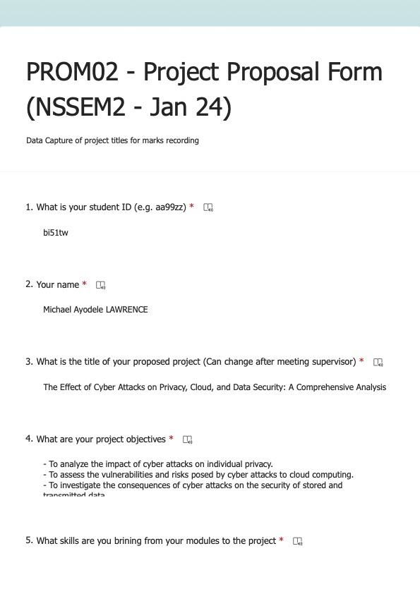

1. Ethics Approval



Appendix C. Source Codes  
  
├── eks_alb  
│ ├── api_server_endpoint.sh  
│ ├── data.tf  
│ ├── main.tf  
│ ├── outputs.tf  
│ ├── providers.tf  
│ ├── s3.tf  
│ ├── terraform.tfvars  
│ ├── variables.tf  
│ ├── versions.tf  
│ ├── web-ec2.pem  
├── eks_cluster  
│ ├── assume_role_policy.json  
│ ├── data.tf  
│ ├── main.tf  
│ ├── outputs.tf  
│ ├── providers.tf  
│ ├── s3.tf  
│ ├── terraform.tfvars  
│ ├── variables.tf  
│ ├── versions.tf  
│ ├── web-ec2.pem  
├── eks_deletion  
│ ├── api_server_endpoint.sh  
│ ├── data.tf  
│ ├── main.tf  
│ ├── providers.tf  
│ ├── s3.tf  
│ ├── terraform.tfvars  
│ ├── variables.tf  
│ ├── versions.tf  
│ ├── web-ec2.pem  
├── modules  
│ ├── argocd_netflix  
│ │ ├── argocd.tf  
│ │ ├── data.tf  
│ │ ├── variables.tf  
│ │ ├── versions.tf  
│ ├── alb  
│ │ ├── alb.tf  
│ │ ├── outputs.tf  
│ │ └── variables.tf  
│ ├── asg  
│ │ ├── asg.tf  
│ │ ├── outputs.tf  
│ │ └── variables.tf  
│ ├── eks  
│ │ ├── bastion.tf  
│ │ ├── eks.tf  
│ │ ├── data.tf  
│ │ ├── outputs.tf  
│ │ └── variables.tf  
│ ├── iam  
│ │ ├── iam.tf  
│ │ ├── outputs.tf  
│ │ └── variables.tf  
│ │ └── data.tf  
│ ├── eks_alb  
│ │ ├── alb_target_group.tf  
│ │ ├── argocd_credentials.tf  
│ │ ├── data.tf  
│ │ ├── iam.tf  
│ │ ├── sg.tf  
│ │ ├── local_value.tf  
│ │ ├── outputs.tf  
│ │ └── variables.tf  
│ ├── eks_deletion  
│ │ ├── data.tf  
│ │ ├── main.tf  
│ │ └── variables.tf  
│ ├── sg  
│ │ ├── outputs.tf  
│ │ ├── sg.tf  
│ │ └── variables.tf  
│ └── vpc  
│ ├── outputs.tf  
│ ├── variables.tf  
│ └── vpc.tf

#IAM Role

resource "aws_iam_role" "cv-banking-WAF-Role" {

name = "cv-banking-WAF-Role-${var.cgid}"

assume_role_policy = jsonencode(

{

Version = "2012-10-17",

Statement = [

{

Action = "sts:AssumeRole"

Principal = {

Service = "ec2.amazonaws.com"

}

Effect = "Allow"

Sid = ""

}

]

}

)

managed_policy_arns = [

"arn:aws:iam::aws:policy/AmazonS3FullAccess"

]

tags = merge(local.default_tags, {

Name = "cv-banking-WAF-Role-${var.cgid}"

})

}

#IAM Instance Profile

resource "aws_iam_instance_profile" "cv-ec2-instance-profile" {

name = "cv-ec2-instance-profile-${var.cgid}"

role = aws_iam_role.cg-banking-WAF-Role.name

}

#Security Groups

resource "aws_security_group" "cv-ec2-ssh-security-group" {

name = "cv-ec2-ssh-${var.cgid}"

description = "CloudVuln ${var.cgid} Security Group for EC2 Instance over SSH"

vpc_id = aws_vpc.cv-vpc.id

ingress {

from_port = 22

to_port = 22

protocol = "tcp"

cidr_blocks = var.cv_whitelist

}

egress {

from_port = 0

to_port = 0

protocol = "-1"

cidr_blocks = [

"0.0.0.0/0"

]

}

tags = merge(local.default_tags, {

Name = "cv-ec2-ssh-${var.cgid}"

})

}

resource "aws_security_group" "cg-ec2-http-security-group" {

name = "cg-ec2-http-${var.cgid}"

description = "CloudVuln ${var.cgid} Security Group for EC2 Instance over HTTP"

vpc_id = aws_vpc.cv-vpc.id

ingress {

from_port = 80

to_port = 80

protocol = "tcp"

cidr_blocks = var.cv_whitelist

}

egress {

from_port = 0

to_port = 0

protocol = "-1"

cidr_blocks = [

"0.0.0.0/0"

]

}

tags = merge(local.default_tags, {

Name = "cv-ec2-http-${var.cgid}"

})

}

#AWS Key Pair

resource "aws_key_pair" "cv-ec2-key-pair" {

key_name = "cv-ec2-key-pair-${var.cgid}"

public_key = file(var.ssh-public-key-for-ec2)

}

#EC2 Instance

resource "aws_instance" "ec2-vulnerable-proxy-server" {

ami = "ami-0a313d6098716f372"

instance_type = "t2.micro"

iam_instance_profile = aws_iam_instance_profile.cv-ec2-instance-profile.name

subnet_id = aws_subnet.cv-public-subnet-1.id

associate_public_ip_address = true

vpc_security_group_ids = [

aws_security_group.cv-ec2-ssh-security-group.id,

aws_security_group.cv-ec2-http-security-group.id

]

key_name = aws_key_pair.cv-ec2-key-pair.key_name

root_block_device {

volume_type = "gp2"

volume_size = 8

delete_on_termination = true

}

provisioner "file" {

source = "../assets/proxy.com"

destination = "/home/ubuntu/proxy.com"

connection {

type = "ssh"

user = "ubuntu"

private_key = file(var.ssh-private-key-for-ec2)

host = self.public_ip

}

}

user_data = <<-EOF

#!/bin/bash

apt-get update

apt-get install -y nginx

ufw allow 'Nginx HTTP'

cp /home/ubuntu/proxy.com /etc/nginx/sites-enabled/proxy.com

rm /etc/nginx/sites-enabled/default

systemctl restart nginx

EOF

volume_tags = merge(local.default_tags, {

Name = "CloudVuln ${var.cgid} EC2 Instance Root Device"

})

tags = merge(local.default_tags, {

Name = "ec2-vulnerable-proxy-server-${var.cgid}"

})

}

Python Code for brute force to DB:  
  
import pymysql

import itertools

# Database connection details

db_host = "database_server_ip" # Target database server IP

db_user = "root" # MySQL username

db_name = "database_name" # Target database name

password_list = [

"password123", "admin", "root", "123456", "password", "letmein",

# Add more passwords as needed

]

def attempt_login(password):

try:

connection = pymysql.connect(

host=db_host,

user=db_user,

password=password,

database=db_name,

connect_timeout=5 # Short timeout to avoid delays

)

connection.close()

return True

except pymysql.MySQLError:

return False

def brute_force_attack():

for password in password_list:

print(f"Trying password: {password}")

if attempt_login(password):

print(f"Success! Password found: {password}")

return password

print("Brute-force attack failed. No valid password found.")

return None

if __name__ == "__main__":

found_password = brute_force_attack()

if found_password:

print(f"Access granted with password: {found_password}")

else:

print("No valid password found. Unable to access the database.")